FINAL REPORT

Title: Database-Driven Budgeting System with OCR-Based Receipt Scanning for Automated Expense Tracking

Honour Code
I hereby confirm that the work presented here in this report and in all other associated material is wholly my own work.
Name:
Date: __________
Signature: __________

Creative Commons License
This work is licensed under a Creative Commons Attribution-Noncommercial-No Derivatives 4.0 International License.

Abstract
Personal financial management has become a universal problem regardless of the active development of financial technologies and digital banking services. Although there are a lot of budgeting applications, many of them do not support the long-term user interaction because of the manual data input and disjointed financial reports. The proposal of designing and implementing a database-based budget system with inbuilt Optical Character Recognition (OCR) to scan receipts and automatically track expenses is the current project.
The system will reduce the work of the users as it will assist in automatic retrieval of transaction details such as date, vendor and total amount of receipts. Such data are manipulated, checked and stored in a structured relational database in order to be sure of integrity and scalability. There is also automated categorisation of the systems, real budget monitoring and interactive visual dashboards to enhance the degree of user access and financial awareness.
The prototype application is developed which can demonstrate how the OCR technology, database design and budgeting logic can be combined. It is a system that is tested on the grounds of accuracy of OCR, usability and effectiveness in comparison to the traditional methods of manual entry. It has been found that automation significantly improves the user experience and tracking reliability in addition to providing satisfactory accuracy levels.
The study is not only technically but also academically pertinent in the sense that it is a consolidation of the different computing disciplines into one solution. It also deals with behavioral problems in financial management through reducing friction in data capture. The findings suggest the effectiveness of intelligent automation to improve the performance of the personal financial management system with the combination of intelligent automation and user-centred design.

Chapter 1: Introduction

1.1 Background and Motivation
Personal financial management (PFM) is generally regarded as a basic factor of personal financial security and future financial prosperity. Proper budgeting assists in controlling the amount spent, reduce debt, save money and achieve the short term as well as the long term financial goals. Personal financial management has never been in a more complex economic environment where consumers are bombarded with a range of payment systems and financial products than at the present time. Still, despite the scalding growth of online banking and financial technologies (fintech) applications, many individuals are unable to afford to meet their daily needs and adhere to the budgeting practice (Lusardi and Mitchell, 2014). This continual dilemma is one of the key contradictions in the exposure of financial instruments and the actual application in improving financial behaviour.
Existing research suggests that good financial management cannot exist without financial literacy. Although people can have theoretical knowledge on the principles of budgeting, saving, and monitoring of expenses, such knowledge in most cases do not translate to regular financial behaviour. One of the primary factors that cause this gap is the absence of practical mechanisms that support the financial habits and control them on a regular basis. It is noted in the literature on behavioral finance that individuals are prone to cognitive biases, procrastination, and impulsive spending which can negatively affect rational financial planning. In this respect, regular tracking of revenues and expenditures with the assistance of accessible and user-friendly tools plays an important role of ensuring financial discipline (Xiao and O’Neill, 2016). However, many of the existing budgeting systems do not provide user involvement in the long-term horizon due to the usability, complexity and manual data input.
The other major problem in personal budgeting is the breakdown of financial records. In everyday life, financial transactions are recorded in different channels i.e. paper receipts, bank statements, online payment confirmations, and notes or spreadsheets that are stored manually. The result of such diffusion of data sources are lack of uniformity and high possibility of incomplete or inaccurate financial records. Among such formats, the paper receipts are one of the most problematic sources of financial data. They are highly susceptible to physical damage, loss and misplacement and it has to be typed manually in digital systems to be subjected to meaningful analysis. This paper based data entry is prone to introduce inefficiencies and the potential of human error and further decreases the trustworthiness of financial records.
The burden associated with the cost is cognitive and time-based on the users of the manual process of capturing costs. Individuals are forced to make interpretations of the information received, identify the information necessary to proceed with the transaction, such as the name of the merchant, date and value and categorize such costs. This most often is a monotonous and tiresome procedure that might discourage the users to maintain regular records. This friction will reduce motivation and lead to inconsistent budgeting tools in the long-term. Thus, the amount of people who abandon financial management applications immediately after the initial usage is high. This trend of behavior implies that not only are the limitations of most of the existing systems related to the functionality of the system but can be largely explained by the inefficiency of the process of data capture and input. In other words, the user experience of the process of filling financial information is more pertinent to the adoption and further use than the analytical aspects of the system.
Technological improvements, particularly in document processing and artificial intelligence, can help to address the challenges. Optical Character Recognition (OCR) is a technology that is supposed to read printed or handwritten text and convert it into a machine-readable form (Smith, 2007). OCR enables the automatic identification of textual data in the hard copy documents such as receipts, invoices, and forms. In recent years, the performance of OCR systems has been increased many times due to the introduction of the deep learning methods that allow them to react to the alterations in font types, layouts, and image quality more accurately (Bengio et al., 2017). This technology has made OCR more relevant to the real life application like financial document processing where there is need to extract data in structured and semi structured formats.
Parallel to OCR, there exist relational database management systems (RDBMS) that offer a stable and organised way of storing and manipulating financial information. The RDBMS systems offer integrity in data both through schema, keys and constraints, and also offer effective querying and transaction management (Elmasri and Navathe, 2016). The characteristics prove useful particularly in financial tasks where the consistency, accuracy and traceability of records is crucial. RDBMS enables order of the data into structured tables, making it simpler to access, combine, and examine the financial activities and make useful conclusions about their expenditure patterns.
With these technological advances, however, there is a significant gap between digitization of receipts technologies and individual budgeting systems. The majority of the financial applications available are either manual data entering based or connected to banking systems to retrieve information about the transactions. Integration of banks comes in handy in tracking electronic transactions, but in the majority of situations they fail to record cash-based expenses that still prevail in most of the world. As a result, a lot of the individual financial activity has not been documented or under recorded in the digital systems. This limitation has the effect of dragging the real life financial behaviour out of context with the data that can be analyzed in the budgeting applications.
Furthermore, the existing solutions involving receipt scanning are typically not combined in large budgetary systems rather are applied as standalone instruments. Such applications can process data on receipts, but not necessarily provide such capabilities as classification of expenses, budget management, or financial visualisation within one application. Lack of integration also renders such systems less effective as users need to work with multiple tools to manage their finances, which complicates them and makes them less convenient to work with.
To address these limitations, the given research proposes the development of one system, which will be a combination of the OCR-based receipt scanning system and the relational database and automation of the budgeting functions. The target system will be geared towards easing the capture process of financial information as it will allow one to scan receipts and automatically retrieve relevant transaction information. This information is in turn retained in an organized database which allows easy arrangement and access to financial information. In addition, the system provides real time data on the expenditure behaviour through categorisation and visualisation of the expenditures.
The system will help to reduce the effort of the user by eliminating the manual data entry which will help in improving the user experience. This will reduce the friction that will consequently increase regular usage hence improved financial tracking and awareness. The simplified data input can make a significant difference behaviorally on the interaction of the user and this is where people will be more inclined to adopt a system which is not demand-intensive and will provide immediate payoff.
In summary, the research is motivated by the fact that the gap between the availability of financial management tools and their practical usefulness in the support of user behaviour is not explored well. Despite the development of financial literacy and digital tools, several problems related to usability, manual data entry and data fragmentation continue to be a challenge to effective personal budgeting. This paper seeks to bridge this gap utilizing the OCR technology and the well-organized database systems which will provide a more efficient, integrated, and user-friendly means of personal finances management.

1.2 Research Aim
The major objective of the research is to develop and deploy a database-based budgeting system that is combined with the OCR technology so that the expense data can be automatically extracted and the budget could be monitored in real time. It is an interdisciplinary goal that incorporates the ideas of software engineering, database systems, information extraction and human-centred computing. The research will not only focus on developing a working system but also to establish how effective the system will be in addressing the usability problems in personal financial management.

1.3 Research Objectives
To achieve the research objective, the study will be structured into four objectives.
- The initial aim is to make a thorough literature review. It involves the research of the already existing personal financial management systems, the research of the OCR technology that is able to digitize the receipts, and the research of the principles of database design that can be applied to the financial applications. This is because it attempts to identify the constraints in existence and develops a theoretical foundation with regards to the proposed system.
- The second goal is to come up with a scalable and efficient relational database schema. The database is supposed to help in a systematic storage of the receipts and transactions, help to categorise the expenses, and help to question the budget in real time. The most important issues in this phase should be the data integrity and the elimination of redundancy.
- The third objective is to develop a prototype of the system. This includes the addition of such features as capture or upload of receipts, data extraction via OCR, automatic or semi-automatic expense classification and budget tracking algorithm. The user-friendly interface should be offered in the system to promote interaction.
- The final objective is to analyze the system performance. This will involve checking the accuracy of data extraction with the OCR, testing of usability and user experience, and test of the effectiveness of automated expense tracking compared with traditional manual operations.

1.4 Research Questions
The research is guided by the following questions:
- How can OCR-based receipt scanning be combined with a relational database system to budget??
- What type of database can best support effective categorisation of expenses and budget monitoring in real time?
- To what extent does automated expense capture improve usability and tracking accuracy compared to manual data entry methods?
These questions are focused on technical and user-centred questions of the proposed system.

1.5 Significance of the Study
The research has practical, technical, and academic implications that can be used to interpret its significance.
In a practical perspective, the system will minimize the cost of manual data entry and increase efficiency of tracking expenses. It assists in making informed financial choices and leads to responsible behaviour when it comes to budgeting due to its provision of real-time analytics and automatic notification.
Technically, this research is an advancement towards the intersection of different domains of computing like OCR, database systems and budgeting algorithms. The technologies are not dependent on one another but a blend of all in one architecture is a new trend of handling personal finances.
Academically, the study has a contribution to financial technology, human-computer interaction, and applied database systems. It demonstrates how real life issues can be solved based on the theoretical concepts and this is mainly related to the user behaviour and system usability.

1.6 Structure of the Report
The remainder of this report shall be subdivided into seven chapters. The second chapter is the literature review of existing studies on the subject that focuses on the current studies on the role of personal financial management, OCR technologies and database systems. Chapter 3 discusses the system design and research methodology both architectural and database model. In Chapter 4, the author describes the way the system was implemented, technologies, and the process of development. Chapter 5 evaluates the system based on performance measures and testing by users. The findings are explained in chapter 6 in relation to the literature available, the strengths and limitations. Finally, Chapter 7 is a study conclusion and suggests future research directions.

Chapter 2: Literature Review
The role of personal financial management (PFM) in the financial health and economic sustainability has been an increasing topic of both scholarly research and in the business community. The emergence of financial technologies (fintech) has seen the appearance of numerous digital solutions to help with budgeting and monitoring expenses. However, the interaction with the users and the long-term usage are also critical questions regardless of the development of technology. The chapter is a critical review of the available literature in five major areas namely personal financial management systems, digitizing receipts and Optical Character Recognition (OCR), financial system database design, user behaviour in fintech adoption, and data visualisation in budgeting tools. At the end of the chapter, a conclusion is drawn on the primary gaps in the research that justify the proposed system.

2.1 Personal Financial Management Systems
Personal Financial Management (PFM) is a significant field of financial technology due to its direct relationship with the financial well-being and the general economic well-being of the individuals. The first research works on this area were predominantly connected to the impact of financial literacy on financial behaviour. Indicatively, establishing a positive correlation between financial knowledge, responsible financial practices by Hilgert, Hogarth and Beverly (2003) means that the more the literate individuals are, the more likely they to budget their money and manage their debts. On the same note, Lusardi and Mitchell (2014) avers that financial literacy also helps in enhancing savings behaviour and retirement planning.
Another examination of the literature will however reveal that there is a significant weakness in these studies that is that they assume that knowledge is automatically translated into behaviour. This assumption is then refuted by other studies that indicate the gap between the knowledge of finances and actual financial practice. Xiao and O’Neill (2016) emphasize that financial discipline is more sustainable in terms of behavioral monitoring and constant feedback rather than in terms of knowledge only. It is a radical shift in the PFM research since the knowledge based methods have been replaced by behaviour based approaches.
Modern digital PFM applications such as Mint and Goodbudget attempt to operationalize these behavioural concepts by providing automated tracking, categorisation and feedback. Mijić and Ćebica (2023) demonstrate that such an application increases the financial awareness of people and can make them make more appropriate decisions. Additionally, Prawitz et al. (2006) and Fernandes, Lynch and Netemeyer (2014) highlight that real-time feedback mechanisms enhance financial confidence and financial stress.
With these developments, user retention is a significant challenge. According to Haddad and Hornuf (2019), a significant number of users quit using PFM applications because of the manual data entry and the need to categorise transactions. Dietvorst, Simmons and Massey (2015) observe this observation since users will discontinue using systems that require manual input to acquire repetitive information, yet the system might be providing the correct insights.
A critical review of systems available has revealed that they are highly functional though in most instances they cannot be used. Most of the applications are highly user-driven and this is a friction point and not conducive to long-term use. Moreover, the research conducted by Karlan et al. (2016) and Leonard, (2008) indicate that behavioral nudges and automation are the key to enhancing financial behaviors.
Therefore, the literature indicates that there is an actual gap in systems that demand less user input and at the same time are precise. The use of automated data capture systems such as OCR can be considered as a potential solution to this weakness. It is in line with the larger trend of user-centred design in fintech, where functionality is not the sole consideration but also a lessening of cognitive and operational loads.

2.2 Receipt Digitization and OCR Technologies
Data capture is one of the major concerns regarding digital financial systems, particularly regarding expense tracking. Receipts are abundant in terms of the transactional information but hand entry is time consuming and liable to mistakes. One of the possible solutions to this problem that has been strongly recommended is Optical Character Recognition (OCR).
The initial OCR solutions depended on pattern recognition methods based on rules, which restricted their application in the process of working with various types of documents (Smith, 2007). These systems experienced an issue of font, layout, and image quality hence poor accuracy rates. Nevertheless, with the development of machine learning and deep learning, OCR has become much better. As Bengio, Goodfellow and Courville (2017) point to, Convolutional Neural Networks (CNNs) and Recurrent Neural Networks (RNNs) may be applied to make text recognition more accurate.
The recent research proves that domain-specific OCR models can be highly accurate in case they are trained on specialized datasets. Neng (2022) provides an example of OCR systems that are specialized in processing receipts and are better than general-purpose models. On the same note, Huang et al. (2019) and Katti et al. (2018) show that deep learning architectures are effective in extracting structured information in semi-structured documents.
Despite these developments, some of the challenges exist. According to Lombardi and Marinai (2020), the quality of images and the state of lighting, along with the variability of documents, are the important parameters that define real-world OCR performance. The receipts are another challenge since they are not always similar in format as they have different layouts. Clausner et al. (2017) also state that OCR systems do not have a high ability to generalize across document types.
The other important limitation is the absence of semantic understanding. The OCR systems are primarily employed to convert pictures into text but not interpretation of the text. According to Lazic (2020), the identification of important fields like the total amount or the date of transaction needs further processing. To overcome this, researchers have thought of using OCR and Natural Language Processing (NLP) as well as rule-based extraction techniques.
Raoui-Outach et al. (2017) demonstrate that OCR using domain-specific models produces an improved field extraction. Equally, Palm et al. (2019) suggest end-to-end document understanding models that combine text detection and semantic classification. However, these techniques usually require massive datasets and training.
The critical gap in the literature is that OCR and practical financial systems have not been integrated. Most of the studies focus on improving the precision of OCR in isolation, and the studies do not concern its application in budget systems. This generates a gap between the technical ability and practical application.
The proposed system will address this gap by integrating OCR with a database storage system and budgeting facilities hence bridging the gap between data extraction and its real application.

2.3 Database Design for Financial Systems
An efficient data storage, retrieval and integrity management is a key element to the success of financial applications, especially those involving high frequency transactional data. These systems are the most prevalent paradigm of financial systems because of their structured nature of relational Database Management systems (RDBMS), the ACID (Atomicity, Consistency, Isolation, Durability) properties, and the fact that they can have strict data constraints (Elmasri and Navathe, 2016; Coronel and Morris, 2019). These characteristics are specifically significant in a budgeting system where accuracy and dependability are directly connected to the financial decision-making.
One of the fundamental concepts of relational database design is normalization, whereby the data is broken down into several related tables to remove redundancy and assure dependency integrity. According to Ramachandran (2018), the financial systems require normalization up to Third Normal Form (3NF) to prevent the existence of anomalies when inserting, deleting, and updating the data. However, normalization as much as enhances uniformity can overdo it and create a complex join which may have adverse effects on performance in real-time applications (Silberschatz et al., 2002). This brings about a compromise between the integrity of the data and the efficiency of the system, which should be well balanced in budgeting systems with high frequency of queries.
Along with normalization, indexing is important in optimizing the performance of queries as well. The works of Garcia-Molina, Ullman and Widom (2008) demonstrate that indexing can significantly reduce the time used to access large data sets, particularly when the query involves time-series financial data where a query can involve a date range as well as filters on category. This has been strengthened by Abadi (2012) who claims that the efficient indexing schemes are paramount to analytical loads of financial applications.
Furthermore, referential integrity constraints ensure that relationships between objects are also uniform. With the association of the transactions and users and categories using the foreign key given as an example, it will avoid orphan records and ensure logical consistency of the database (Date, 2019). Such mechanisms are critical in financial systems which may result to poor budgeting and misleading information due to inconsistency of the data.
These are the strengths of RDBMS, but there are other database paradigms that have been considered like the NoSQL because of their flexibility and scalability. No SQL databases include document-based and key-value databases that are at least desirable in dealing with unstructured data and data streams with high velocity (Han, Haihong and Du, 2011). Stonebraker and Çetintemel (2018), however, assume that NoSQL systems have weakened scalability likely at the cost of consistency and therefore do not be the optimal solution in financial applications that must provide strong transactional assurances.
The studies of hybrid database architectures that take the advantages of both relational and NoSQL systems have been recently performed. Fikri et al. (2019) state that unstructured data (raw OCR results) get stored in a NoSQL database system, and structured financial data are stored in relational systems. Likewise, another issue mentioned by Pokorny (2013) is also the possibilities of a multi-model database to support various types of data on the same platform. These approaches allow flexibility but make it even harder to have an integrated data, consistency, and maintenance of the system.
Scalability and performance optimization is another issue that is of great relevance in the database design of financial systems. According to the authors, the popularity of the distributed database systems and cloud-based architecture grows in the matters of working with big financial data (Ozsu and Valduriez 2020). Nevertheless, these systems should not be detrimental to consistency and reliability especially when it is used in budgeting applications where a single variance can have innumerable impacts.
Critically, the literature is very compelling in the usage of RDBMS in financial application because of their reliability, structured schema and strong consistency. However, it also indicates the emergence of the new problems of scalability, performance, and integration with unstructured data sources. The system proposed uses a relational database model to maintain integrity of data and also uses effective schema design and indexing measures to ensure maximum performance. The hybrid methods may be beneficial, but the complexity of hybrid methods is an issue when using small to medium budgeting systems.
In summary, database design of a financial system should be well balanced on the factors of consistency, performance, and scalability. Even though RDBMS remains the best solution in the structured financial data, this could be improved in future systems with hybrid architecture that is intelligent enough to draw structured and unstructured data processing.

2.4 User Behaviour and Fintech Adoption
User behaviour critically depends on the success of financial technology (fintech) applications. Despite the fact that use of technology has significantly increased the functionality of the budgeting tools, the users have a big challenge in the adoption and further use of the tool. Technology Acceptance Model (TAM) proposed by Davis (1989) provides a theoretical framework of user adoption where the two aspects of behavioral intention determinants are perceived usefulness and perceived ease of use. Later Venkatesh and Bala (2008) extended this model and included other variables such as system design and user experience.
Empirical research will always show automation is significant in enhancing user interaction. Naik et al. (2024) propose that users will consistently adopt financial apps when the applications lower the quantity of manual entries and provide automated information. Similarly, Oliveira et al. (2016) also mention that ease of use is one of the most significant determinants of the adoption of mobile banking and financial apps. These findings are agreeable with the behavioral economics theories, which suggest that the less thinking process in decision making, the more individuals are likely to follow up normal activities (Leonard, 2008).
However, despite such developments, usability problems still exist. According to Dieter and Tkacz (2020), users tend to classify transactions in the wrong way or do not update expense categories resulting in the inaccuracy of financial analysis. The Ferreira et al. (2014) study also supports the problem, saying that the manual categorisation is prone to human error and inconsistency. These restrictions underscore the importance of smart systems that can minimize the involvement of the user and still provide the accuracy.
To address such problems, researchers have explored machine learning-based categorisation systems. According to Baker and Dellaert (2017), personalised recommendation system has the potential of improving user experience since transactions are automatically classified according to past behaviour. Similarly, Van der Aalst (2016) notes the potential of predictive analytics in order to improve decision-making within financial systems. Despite the potential results, the techniques require large data sets, processing and sophisticated algorithms, which are not always relevant to every application.
Another important variable of user behaviour is trust and perceived security. Kim, Shin and Lee (2009) consider that the trust is an important element in the utilization of fintech services. Users will be ready to operate with those systems which can ensure the privacy and security of data. This is particularly in regard to the budgeting applications that handle sensitive financial information.
Another critical gap in the literature is the absence of the combination of behavioral insights and technical design. Whereas studies that focus on user experience and studies that focus on the functionality of a system exist, there are not many that endeavor to combine both. As an example, Marjanovic et al. (2019) suggest that to be successful, fintech applications have to be aligned with the technical capabilities and user behaviour in order to attain sustained engagement.
The proposed system will address this gap by integrating automation with user-based design. Technological and behavioral alignment of the system is also minimized through limiting the manual labor by applying OCR data capture and the visualization functions are simple to use and display. It must be noted though that the behaviour of the user is influenced by other factors which include motivation, financial literacy, and personal habits that cannot be completely solved by the technology solutions.
In conclusion, the literature demonstrates the importance of usability, automation, and trust with regard to adopting fintech. In spite of the fact that technology has helped increase the capabilities of the systems, user behaviour is a complex and multifaceted problem. The proposed system adds to this area, integrating behavioral knowledge with technical innovation though additional studies are required to know long-term engagement of the user.

2.5 Data Visualisation in Budgeting Systems
Data visualisation plays an important role in transforming the complicated financial data into meaningful information that can be applied in the decision-making process. In the context of budgeting systems, the visualisation assists the users to understand the trend of spending, identify trends, and make prudent financial decisions. Few (2013) indicates that the main qualities of a good dashboard are that they must be crystal clear, relevant and actionable, without bombarding users with excessive information.
Common visualisation tools employed in finance include pie charts, bar charts, and time-series graphs. Pie charts would be suitable in the presentation of proportional data, such as the distribution of the expenses in different categories, whereas bar charts would be suitable in comparing the data in different categories (Kirk, 2019). The time-series graphs are also effective when investigating the trends in time that enables a user to follow the changes in the spending behaviour.
However, quality visualisation lies on quality design. Tufte (2001) says that bad visualization may distort data and mislead the user. Cairo (2016) also supports this reasoning by assuming that in order to communicate successfully, a person must be capable of being straightforward and simple. The dashboards can be too complex, which can decrease the usability and user engagement.
Interactivity is the other significant feature of data visualisation in the contemporary era. Yigitbasioglu and Velcu (2012) found out that the interactive dashboards are highly user engaging because the user can explore the data interactively. Filtering, zoom and drill-down analysis enables the end user to customize the experience by seeing the most useful parts. Another point that Heer and Shneiderman (2012) highlight is the fact that interactive visualizations facilitate data exploration and understanding.
Despite the developments, the majority of the existing budgeting programmes provide flat or low level visualizations that reduce user interaction and reduce their utility. The study conducted by Sarikaya et al. (2019) indicates that the application of the static visualization is not applicable in the complex decision making process particularly in financial cases where the data is multidimensional.
Another important factor is personalization. Munzner (2014) says that visualisation systems are supposed to be flexible to the needs and preferences of the user. Dashboards will also improve user experience as the relevant information will be presented in the personalized format using individual dashboards. However, the implementation of such systems requires sophisticated design and computing resources.
Critically, data visualisation is not just the tool of presentation but part and parcel of financial systems. It directly affects user understanding, evaluation and interaction. The absence of the appropriate visualisation design can ruin even the most advanced systems.
The proposed system will deal with these shortcomings by including interactive dashboards and various visualisation methods. The system is user friendly because it allows one to filter information and make informed decisions of spending patterns. However, further improvements can be introduced with the adaptive visualisation, and custom dashboards that will be more responsive to the requirements of individual users.
In a summary, the literature has highlighted the importance of clarity, interactivity, and personalization in data visualisation. Despite the big way progress that has been made, most of the systems that are in place fail to utilize such principles to their fullest. The offered system is an extension of this sphere since the interactive and user-friendly visualisation features are applied here, yet it can be enhanced.

2.6 Synthesis and Research Gap
The literature demonstrates that there is tremendous improvement in the individual components of the personal financial management system i.e. budgeting tools, OCR technologies, database systems and data visualisation. However, some of the key gaps exist.

1. Integration Gap
Most of the existing systems are either budgetary or digitisation of receipts but not both. Minor information is provided on the integrated systems that combine OCR, database storage, and budgeting functions in one architecture (Raoui-Outach et al., 2017).

2. Semantic Extraction Gap
Although OCR is able to extract text, it does not comprehend the meaning of the receipt data completely. More processing is required to classify transactions and match them to the budget categories (Lazic, 2020).

3. Usability and Behaviour Gap
Most systems fail because of low user engagement. No research is presented in the literature that combines behavioral knowledge with automatic systems to promote the adoption in the long term (Naik et al., 2024).

4. Data Capture Efficiency Gap
Manual data entry has been identified as one of the greatest hurdles in the budgeting systems. Not many research works provide possible solutions to eliminate such friction totally.
The chapter has critically analysed literature available on personal financial management, OCR technologies, database systems, user behaviour and data visualisation. Whilst a lot has been done, these aspects have no integration with the existing systems and this imposes a limitation on the existing systems.
The research gaps indicated above demonstrate the necessity to consider a single solution, which integrates automated data capture, structured storage, and the ease of design. The proposed system will address these problems through the integration of OCR-based receipt scanning, a relational database and real-time budgeting features.

Chapter 3: Methodology and System Design
This chapter outlines the methodology and system design that will be used in the creation of the proposed database-based budgeting system with the Optical Character Recognition (OCR). It identifies the research methodology, system specifications and architecture, which provides a clear point of implementation and analysis. The methodology is well designed in that, the system is not only technically sound but also in line with the needs of the user and behavioural concerns.
The interdisciplinary nature of the project pre-determines the approach that involves the concepts of software engineering, database systems, human-computer interaction, and machine learning. The integration will assist in the development of an all-embracive solution that will not only address the technical issue, but also the usability problem. The prime goal is to create a real practical artefact and to undertake a systematic evaluation of the usefulness of the artefact in improving individual financial management.
The methodological approach applied to the given research is Design Science Research (DSR), as this approach is concerned with the development and test of new artefacts aimed at resolving real-world problems (Hevner et al., 2004). This method is especially appropriate to this project, since it aims at creating a practical system that would solve inefficiencies in the expense tracking and add to the academic knowledge.

3.1 Research Methodology

3.1.1 Design Science Research Approach
The current research follows the Design Science Research (DSR) approach that is commonly known in information systems research due to its emphasis on artefact construction and testing. Compared with the strictly theoretical approach, DSR is more concerned with the development of practical solutions that would address the identified problems as well as contribute to the body of scientific knowledge (Hevner et al., 2004).
The artefact in this study is a database-based budgeting system that incorporates OCR technology in order to track expenses automatically. The rationale of the DSR could be presented by the need to design, implement, and experiment a system that will directly address the limitations that have been identified in the existing tools of personal financial management.
The DSR process in this study is structured. The initial step is problem identification, in which the ineffective expense tracking has been identified as a major problem because of using manual data entry and disjointed financial records. The literature that supports this question is that the high level of effort results in the disengagement of the user in the budgeting systems (Xiao and O’Neill, 2016).
The second phase involves establishing the research objectives, which revolve around creation of an automated system that will make data capture simple and budgeting efficient. This phase makes sure that the study is consistent with the practical requirements and academic objectives.
The third stage involves the system design and development. Such includes creation of system architecture, database schema and OCR integration mechanisms. Software engineering and database management have set principles to steer the design stage towards reliability and scalability (Pressman, 2014).
The fourth stage is demonstration whereby a prototype is developed to demonstrate how the system works. This enables practical validation of design decisions and gives grounds to future evaluation.
The fifth stage is the evaluation stage in which the system shall be tested on its main performance indicators such as the OCR accuracy, usability, and effectiveness as compared to the manual expense tracking methods. This makes the artefact achieve its intended goals.
Lastly, the communication phase entails the writing of the findings and the presentation of the results in a form of a report. The stage assists in academic knowledge through sharing of ideas and lessons learnt.
Overall, the DSR methodology ensures that there is a balance between theoretical rigour and practical relevance, and that is why it is quite suitable in this study.

3.1.2 Research Strategy
Mixed-method research strategy is applied to give a comprehensive analysis of the proposed system. It is a quantitative and qualitative methodology which focuses on both technical performance and the user experience.
The qualitative component will encompass a critical literature survey and a system design analysis. This will help in the realization of existing problems in the personal financial management systems and justification of design decisions. It is also possible to critically evaluate the existing technologies such as OCR and database systems.
The quantitative aspect is concerned with system assessment measures. These are OCR accuracy rates, system response times and performance efficiency. This is because the measurement of these factors will present objective evidence of system effectiveness as a study outcome.
The qualitative and quantitative approaches are employed to ensure that they have a holistic picture of the system. It allows the study to encompass both the technical functionality as well as the user centred dimensions that are critical in the high rate of usability and adoption.

3.2 System Requirements Analysis

3.2.1 Functional Requirements
The functional requirements outline the fundamental functions that the system should execute in order to fulfill its goals. These are requirements based on the problem and needs of the user identified.
The system must be capable of registering and authenticating users to gain a secure access to personal financial data. It should allow its users to capture or upload receipt pictures through mobile interfaces or through web interfaces and must be adaptable in terms of how users input data.
One of the features of the system is the text extraction based on OCR that allows retrieving the transaction details of the receipt images automatically. Then the parsing and validation processes are undertaken to ensure that the data extracted is accurate and formatted.
The system should store transaction data in a relational database in order to organize and retrieve it in a fast manner. It should also provide automated and manual classification of the expenses to achieve greater accuracy and control by the user.
The features of creating a budget and monitoring it are the necessary ones, as they enable the user to establish a spending limit and monitor their financial transactions in real time. The system should also give alerts when the user is on the edge or outside his budget limit which will assist in proactive management of money.
Also, the system should have visual dashboards that display financial insights in an interactive and easy to understand way. These characteristics make the system fulfill the expectations of the users and overcome the major shortcomings of the current budgeting tools.

3.2.2 Non-Functional Requirements
Non-functional requirements refer to the quality attributes of the system and are essential in ensuring that the system meets the users as well as ensuring that the system works.
The usability is one of the main issues because the system should be easy to use and have a clear interface that reduces the efforts of the users. Studies have revealed that the ease of use plays a major role in the adoption of technology (Davis, 1989).
Performance is another factor that is important particularly in the speed of OCR processing and the time taken to respond to queries in the database. A nice user experience is ensured by high performance, which removes delays in data processing.
Scalability is also required to serve growing amounts of financial data as users keep communicating with the system. The system must be capable of supporting the growth without impacting on the performance.
Security is of particular concern in financial applications. The system should safeguard delicate user information by using safe authentication and data encryption systems.
Reliability ensures that the system can perform its functions on a regular basis without breakdown. Data storage and retrieval are highly critical towards user confidence.
The combination of these non-functional requirements makes the system robust, efficient and easy to use.

3. System Architecture

3.3.1 Overview
The offered system follows the modular architecture that comprises six important modules, such as frontend interface, OCR processing module, parsing and validation module, relational database, budget monitoring engine, and data visualisation module. This design is a modular one and facilitates the separation of concerns where each part can be a complete unit as well as can be a part of the full system.
Maintainability, flexibility, and scalability are enhanced by such approach of architectural style. The software engineering process provides assistance in the development, testing, and extension of modular systems tangibly simpler (Pressman, 2014).

3.3.2 Frontend Interface
The frontend interface is the main interface with the user and the system. It will provide an easy and seamless user experience that will enable users to complete the most vital activities in the system, such as uploading receipts, checking transaction history, budgeting, and financial insights.
The interface allows receipt capture with the help of camera input and file upload, which makes it flexible and convenient. The interactive dashboards allow user to easily navigate their transaction history and monitor their spending habit.
The principles of user-centred design are used to make it easier to use and more accessible. The concepts revolve around simplicity, clarity, and responsiveness, and this implies that the users can interact with the system (Norman, 2013). The frontend design will be significant in making the user interface more engaging and adoptable by making it easier to use and more effortless.

3.3.3 OCR Processing Module
The Optical Character Recognition (OCR) processing module will be a very important component of the proposed system that will convert the pictures of the receipts into machine-readable text. The module facilitates capturing of expense data in an automated manner thus removing manual data entry. There are three general stages in the OCR process, which include, image preprocessing, text detection, and character recognition.
The first step that is significant in improving the accuracy of OCR is image preprocessing. The lighting conditions, the resolution of the camera, the skew and the noise of the background can be greatly differentiated to form the quality of the images received by the users. These problems are overcome by using preprocessing options such as noise reduction, grayscale conversion, binarization and image resizing. All these enhance the clarity of the text and reduce distortion, which makes it easier to identify (Lombardi and Marinai, 2020).
The second step is text detection whereby the system determines areas in the picture that have textual information. This is because the receipts are normally accompanied by logos, graphics and other non-textual features. The existing OCRs are high-tech and apply machine learning models to detect non-text and text regions in order to improve efficiency.
The last step is character recognition, during which the recognized text areas are transformed to digital text. Newer OCR engines such as Tesseract, are grounded on machine learning and deep learning algorithms to achieve high recognition rates (Smith, 2007). A lot of data is fed into such systems, enabling it to recognize various fonts and layouts that are commonly used in receipts.
Irrespective of these inventions, the quality of input and the variation of documents still affect the performance of OCR. That is why, preprocessing and optimization are still regarded as the significant parts of the OCR pipeline which can ensure the reliability of extracted information.

3.3.4 Parsing and Validation Module
The raw OCR output is then fed into the parsing and validation module after text extraction which extracts and structures meaningful transaction information. The text of OCR is usually not structured and may contain mistakes or irrelevant data. Therefore, the module transforms raw text to valuable and meaningful data.
The parsing process will be sought to locate important fields of transactions like the date of transaction, the name of the vendor, the amount of the transaction and tax details where required. This is done by use of rule based methods and pattern matching. One such example is the usage of keywords such as Total, amount or characters of currency (e.g. the use of the $ or pound) to calculate monetary values. On the same note, pattern-defined date formats are also used to identify them (Lazic, 2020).
However, validation is required to use parsing. The result of OCR may be incorrect due to the recognition error and it requires additional verification actions. Data reliability is achieved through the validation process which involves a number of checks. These are filtering of duplicates, numerical value checking, and data retrieved is in the desired format. Examples of this include that the value of transactions should be positive numerical values and dates should be in the appropriate formats of date.
This module is significant in the process of making sure that rawness OCR output is converted into structured database storage. It also enhances reliability of the system since it does not affect the accuracy and consistency of the data.

3.3.5 Relational Database
The relational database is used as the main storage and management of all system information. It matters a lot in ensuring integrity of data, consistency and efficient retrieval. Some of the types of information that will be saved in the database are user profiles, receipts, transactions, categories, budgets, and alerts.
The Relational Database Management Systems (RDBMS) will be used in this project due to its strength and reliability. They make it easy to store data in an organized way and set a limitation that guarantees the integrity of data (Elmasri and Navathe, 2016). As an example, primary and foreign keys are used to assure that interrelationships among entities are properly upheld.
Moreover, relational databases allow complex querying, which is also necessary in financial applications. The efficient database queries provide the users with access to the history of transactions, analysis of spending patterns and budgeting. This renders RDBMS to be especially appropriate in applications that need proper and precise financial information.

3.3.6 Budget Monitoring Engine
Budget monitoring engine comes in play where it monitors the cost incurred by the user with regards to budgets. The module is continuously processing the information regarding the transactions in order to provide real-time data about the spending behaviour.
The engine performs certain significant tasks. First, it measures the aggregate expenditure under various categories. Second, it makes comparisons between the current expenditure and pre-established budgetary constraints. Lastly, it sends alerts when the expenditure is close to or above these thresholds.
Budget monitoring is a major factor that promotes financial awareness by means of automation. The user will become more likely to alter his or her spending behaviour and adhere to financial goals with the help of real-time feedback. According to research, these behavioral feedback mechanisms are very important in enhancing financial discipline (Xiao and O’Neill, 2016).
This module transforms raw financial data into actionable data and therefore is a vital component of the system.

3.3.7 Data Visualisation Module
The data visualisation module will be used to display financial information in an easily comprehensible way. The visualisation must be efficient to help the users to interpret complex data and make sound decisions.
The system utilizes a number of visual aids including bar charts, pie charts and line graphs. These graphs present different aspects of financial information such as category-based spending, monthly variation and budget comparisons. Dashboards are summarised financial performance, a representation which allows the financial user to see their financials at a glance.
Interactivity is also present in the visualisation module. The users can filter the data, navigate through some categories and observe the tendencies in the course of time. These characteristics bring the user closer and user experience more enjoyable.
It has been revealed that properly designed visualizations can facilitate decision-making due to the ease in understanding complex information (Few, 2013). Therefore, the visualisation module is significant in the data to insights transformation process.

3.5 Database Design

3.5.1 Design Principles
The database is developed on the basis of general principles that guarantee efficiency and reliability. These are normalization, referential integrity and indexing.
Normalization reduces redundancy by organizing data into tables. Referential integrity is utilized to help in offering consistency, in the sense that there are healthy associations amid the tables. Indexing improves the speed at which a query is run since it can be performed much faster. The principles are inherent to financial systems where accuracy and efficiency are the most important (Ramachandran, 2018).

3.5.2 Entity-Relationship Model
The system database is created on the basis of the most important entities, including User, Receipt, Transaction, Category, Budget, and Alert. Every entity is a particular feature of the system functionality.
The relationships between these entities are spelt out well. To give an example, a user can have numerous receipts, and a single receipt can consist of numerous transactions. The categories are related to the transactions hence expenses can be categorized. Similarly, the user will be in a position to make different budgets according to categories.
It is an organized approach that facilitates effective data administration and facilitates complex queries which are required in carrying out financial analysis.
(ER Model)

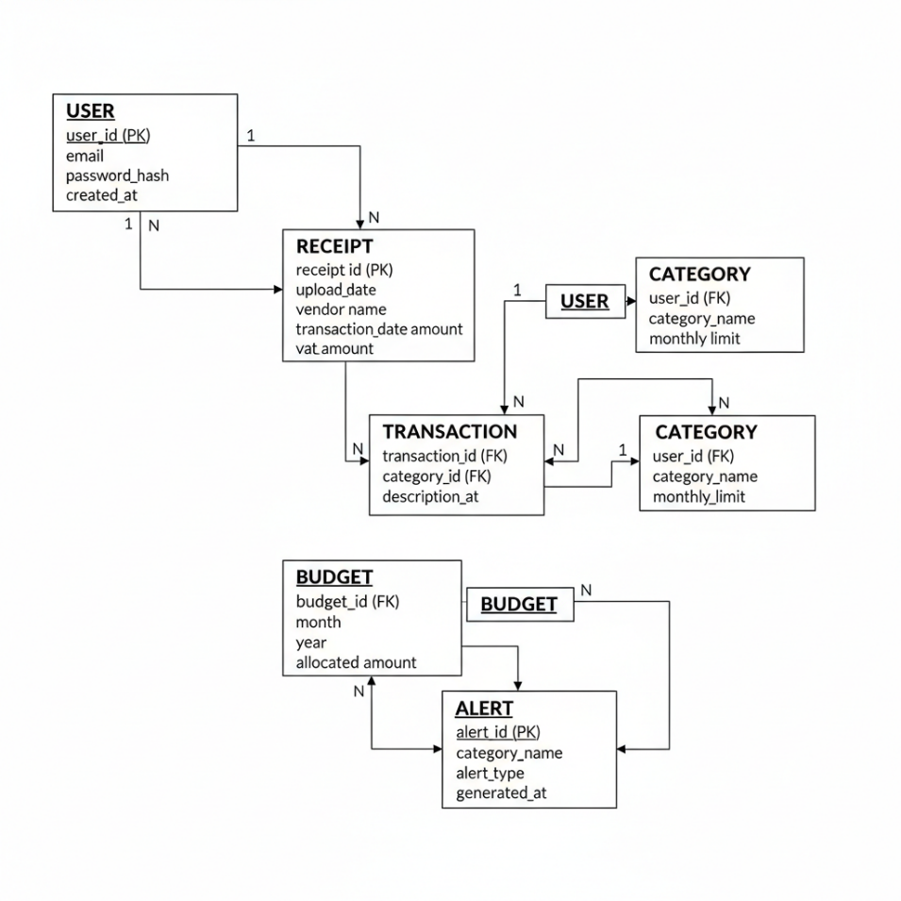

3.5.3 Normalization
It is a normalized database to the Third Normal Form (3NF). This will guarantee that the data will be stored without any redundancy and dependencies will be taken care of. Normalization enhances data integrity by removing redundancy and decreasing storage inefficiency by ensuring consistency (Elmasri and Navathe, 2016).

3.5.4 Schema Design Justification
The type of financial data makes a relational schema a better choice than NoSQL options. Financial systems need a high degree of consistency, organization of data storage and ability to support complex queries.
NoSQL databases are flexible and scaleable, but frequently do not have very strict data integrity constraints. This renders them inapplicable in cases where precision is of essence. According to research, relational databases are still favored in financial applications because they are reliable (Stonebraker and Çetintemel, 2018).

3.6 Algorithm Design
The algorithm design of the proposed system is also a significant factor that determines the level to which the proposed system can manipulate the input data, transform it into valuable information and produce actionable outputs. The system contains a number of algorithms, the purpose of each of which is the entire structure. These are OCR extraction, expense categorisation and budget monitoring algorithms. These algorithms combined allow processing and analysis of financial data to be automated, with minimal human intervention required, and more efficient and accurate.

3.6.1 OCR Extraction Algorithm
The OCR extraction algorithm is the one that converts the images of receipts into machine readable text. The system starts as the user feeds the system via an interface with a picture of a receipt. The next step is to pass this image through a series of actions that would improve its quality and get it ready to be recognized as a text.
The initial step is image preprocessing, and it comprises image processing methods like noise removal, grayscale conversion, thresholding, and resizing. The steps are needed to maximize the clarity of the image and remove distortions that might negatively impact recognition accuracy. Preprocessing is also used to make the text areas of the image more conspicuous, especially in low quality or poorly shot images.
The preprocessing is then applied to the image followed by a text recognition step in which the OCR engine analyzes the image and reads out the text. The OCR engine attempts to identify characters, words and lines matching the patterns to the trained datasets. The OCR systems of the modern world operate according to the machine learning models trained on the huge volumes of text images, that is why they can identify the enormous number of fonts and formats.
Once the text is extracted the system gives an output as raw and unformatted text. This is the output of the subsequent processing modules such as parsing and validation. It should be mentioned that the quality of the input image and the efficiency of preprocessing techniques are very important factors which determine the accuracy of the OCR extraction algorithm. Changes in lighting, distorted images, blurred text, and irregularity of the form of receipt may also affect the OCR system (Neng, 2022).
Through these difficulties, the OCR extraction algorithm greatly minimizes manual data input and forms the basis of the automation capabilities of the system.

3.6.2 Expense Categorisation Algorithm
The expense categorisation algorithm is supposed to take extracted transaction data and place it into meaningful categories. After the text is processed by the OCR the system then takes the unstructured text that holds the information about the vendors, the amount of the transactions and other data. This information is entered into the categorisation algorithm and every transaction is assigned into an existing category.
This is primarily used in rule based approaches. In this process, the categories are correlated with some words and patterns. As an example, one can cluster transactions involving keywords like groceries under a category of Food, but transactions involving keywords such as fuel stations under Transportation. This method is founded on pre-determined rules and lists of keywords which are applied to classify expenses.
In addition to automated categorisation, there is a functionality of manually overriding the category assignment. This feature is flexible and lets users fix any misclassifications that can arise owing to the drawbacks of the rule-based approach. Manual intervention may be particularly useful in cases of ambiguous or unusual descriptions of transactions.
Although the categorisation based on rules is efficient and easy to implement, it has some limitations. It is inflexible and may not be functional in the situations where it encounters new or unfamiliar patterns. To address this, the addition of machine learning models, which improve the accuracy of categorisation with time as user behaviour is monitored, may be added in the future. Such adaptive systems can dynamically respond to individual spending behaviors and provide more individualised categorisation results (Baker and Dellaert, 2017).
Overall, the expense categorisation algorithm plays a vital role in sorting the financial data and making a useful study of the spending habits of users.

3.6.3 Budget Monitoring Algorithm
The budget monitoring algorithm is tasked with the mandate of tracking user spending and ensuring that the spending does not exceed the set limits. This algorithm operates by continuously analysing the data in the database which relate to transactions and comparing it with pre-established budget thresholds.
The first step in this process is to calculate the total amount spent on each category within a certain time. This is done by summing up the transaction values relating to each category. Once the totals are established, the system will compare them with the corresponding budget limits established by the user.
The system will alert the user when the money that has been expended in a given category is similar or exceeds the amount that is budgeted. These warning messages can be displayed on the dashboard or sent as a notification, depending on the settings of the system. These notifications are intended to provide prompt feedback and convince the user to alter his spending habits.
The budget tracking algorithm brings in a proactive financial management. The system does not merely record the expenditures but rather checks and comparatively the spending patterns in a proactive manner. This assists the user to control their finances better and prevent excessive spending.
By including real-time monitoring and alert systems, the system makes the users more conscious and enables them to make informed financial decisions. This is consistent with behavioural financial principles which suggest that timely feedback can significantly influence financial behaviour and increase budgeting discipline.

3.7 Implementation Strategy
The implementation plan is the process through which the system will be developed, integrated, and deployed. It also ensures that the development process is structured, iterative and as required by the system.

3.7.1 Development Approach
The system is implemented in an iterative development. This method includes the division of the development process into smaller steps, which can be refined and improved at every step. The processes typically consist of requirements analysis, system design, implementation, integration, and testing.
In the initial phase, the requirements are gathered and analyzed to become acquainted with non-functional and functional requirements of the system. The design stage follows and entails specifying the system architecture, database schema and algorithmic elements. Coding the front end and back end, OCR functionality and database connections are part of the implementation stage.
This repetitive nature of this process allows the developer to identify the issues as they occur and make the necessary changes before proceeding to the next phase. It also allows testing and validation to be performed continuously, so that each component can be tested and validated before it is integrated.
This approach is particularly beneficial in dealing with complex systems such as the proposed budgeting application, where the different parts must be in a well-coordinated state. Iterative development also enables flexibility because it enables the system to develop more flexibly in response to the feedback and testing results (Pressman, 2014).

3.7.2 Technology Stack
The system is deployed with the combination of the modern technologies that are chosen by their performance, scalability and compatibility. The frontend is developed in React, a dynamic and responsive user interface, as it is designed as a component-based framework.
The back end is done in either Node.js or Python, based on the needs of the application. Such technologies are chosen due to their ability to address asynchronous operations and support the development of APIs.
Relational database management system such as MySQL or PostgreSQL is used in data storage. These databases are tightly normalized to structured financial data and they permit complex queries and data relationships.
The OCR feature is achieved by means of Tesseract OCR engine, which is an open-source application that finds a wide application in the extraction of text in pictures. It is a suitable remedy to this system because it can be used with various programming environments and can be used with diverse languages.
The choice of these technologies will make the system scalable, maintainable, and able to meet the real-world usage conditions.

3.8 Evaluation Methodology
The evaluation strategy will focus on assessing the performance of the system on three key areas which will be the OCR accuracy, usability and the overall performance of the entire system. The quality of OCR is obtained by matching the text extracted to manually checked data to determine the quality of the recognition.
The usability is tested using interaction with the user, feedback, and time to accomplish the task. The experience of users is observed and analysed as they are asked to complete certain tasks, including uploading receipts and reviewing the summaries of their transactions.
Response time, processing speed, and efficiency of database query are used to measure system performance. These tests provide an insight into how the system will perform in normal operating conditions.
All of these evaluation criteria will contribute to getting a clear image of the level of effectiveness of the system and the things that can be improved.

3.9 Ethical Considerations
The system is handling sensitive financial information and therefore ethical considerations play a significant role in designing and implementing the system. The system is charged with the primary role of safeguarding privacy of the user and ensuring that the data is safe.
There are secure authentication processes to eliminate unauthorised access. Moreover, information is secured with the help of data encryption methods when transmitting and storing data. The users themselves control their information too and they can update, delete or modify their financial data at any time.
Transparency is another important ethical consideration. The users must be made aware of the way their data is processed and stored in the system. Openness fosters confidence and embraces users.
By implementing these ethical considerations, the system is not only following the best practices in data management, but also promoting responsible use of sensitive data.

Chapter 4: System Implementation
This chapter includes a step-by-step description of the deployment of the suggested database-based budgeting system which is combined with Optical Character Recognition (OCR). However, despite the fact that the 4th chapter was dedicated to the system design and methodology, the chapter in question critically examines how the decisions made during the system design were then implemented in the form of a working prototype. Its use does not merely represent a technical procedure, but a validation of the feasibility and performance of OCR, database systems and budgeting logic in one platform.
Reducing the friction of the manual financial tracking is one of the functions of such an implementation. However, the effectiveness of the chosen technologies and methods should be evaluated critically to address the challenges that were outlined in the prior chapters and, in particular, the usability, accuracy, and performance of the system.

4.1 Development Environment and Technology Selection
The technologies play a crucial role in determining the performance, scalability and maintainability of the system. In this project, modern web technologies were applied so that it could be adaptable and compatible to different platforms.
React.js was used to develop the frontend and offers a component-based architecture that improves the modularity and reusability. It is particularly helpful in applications that have to be dynamically updated, e.g. financial dashboards. But on the one hand, React allows making the user interface more responsive, but on the other hand, it can create a lot of complexity in state management, which should be managed with care to prevent performance problems.
On the back end, python is used to develop server-side and API. The python is also asynchronous and thus it is effective to handle OCR work and database communication. Nonetheless, it may turn out to be a bottleneck to its one-threaded nature when it comes to high workloads that require optimization methods such as load balancing.
A relational database system (MySQL or PostgreSQL) was adopted to store information. The choice of RDBMS is justified by the fact that the financial data is organized, and should be well consistent (Elmasri and Navathe, 2016). NoSQL databases are more flexible, but they do not enforce data integrity as strict as is required of a financial application.
With the Tesseract OCR engine, the OCR engine was added. The reason why tesseract is popular is because it is open source and can be configured to support different languages (Smith, 2007). Nevertheless, it is very sensitive to the quality of the image, and preprocessing is a very important part of the implementation.
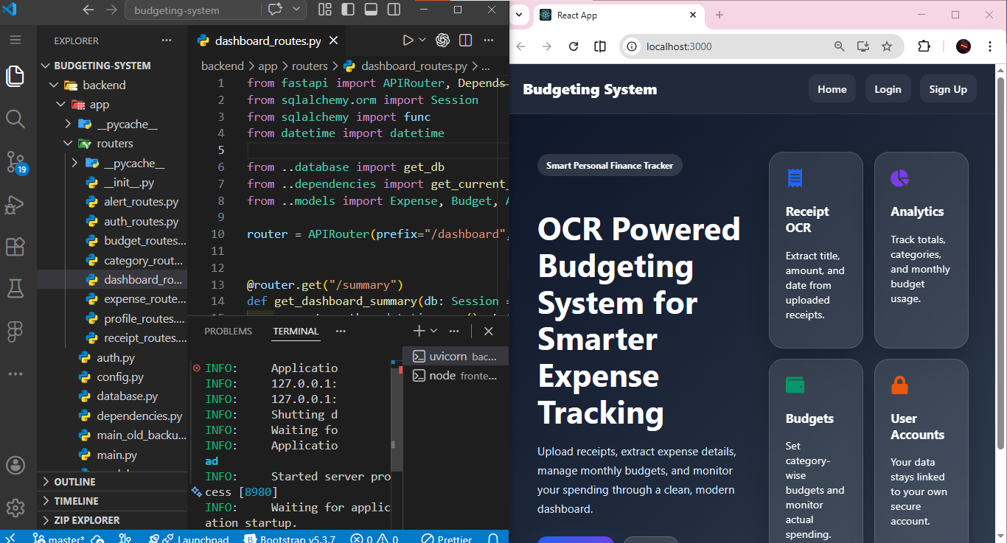
Figure 4.1: Overall System Implementation Showing Frontend Dashboard Connected to Backend OCR Budgeting System

4.2 System Workflow and Integration
The system has a workflow that is systematic and it incorporates various components into a unified process. The user interface starts with the frontend whereby receipt images are uploaded. These images are then processed by the backend and OCR extraction, data parsing are carried out followed by storing the information into the database.
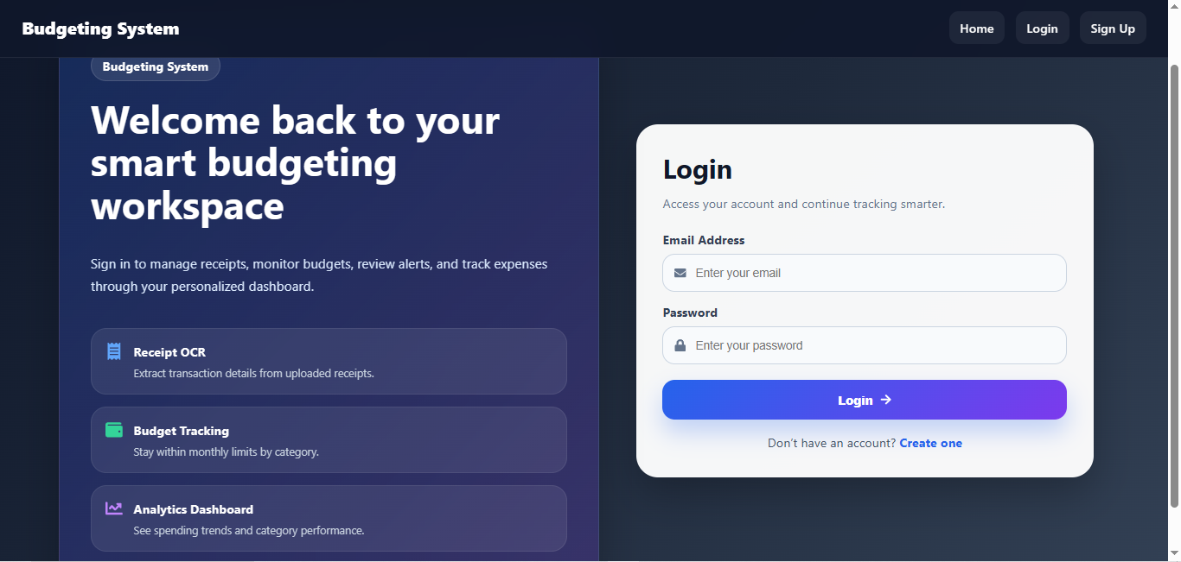
Figure 4.2: User Login Interface for Secure Access to Budgeting System
Among the most powerful advantages of this workflow is the fact that it automatizes the process of data capture and, therefore, addresses one of the most important weaknesses of the existing budgeting systems. The system will reduce cognitive load and enhance user interaction by eliminating manual data entry. Quality of such a workflow is, however, defined by quality of OCR and parsing operations. Any mistakes during these stages may be transferred across the system and this may compromise the accuracy of financial insights.
The other important is the component integration. A smooth communication between the frontend and the backend is achieved with the use of RESTful APIs. Even though this modular style is more scalable and easier to maintain, the latency issues may also occur, particularly when handling high volumes of data.
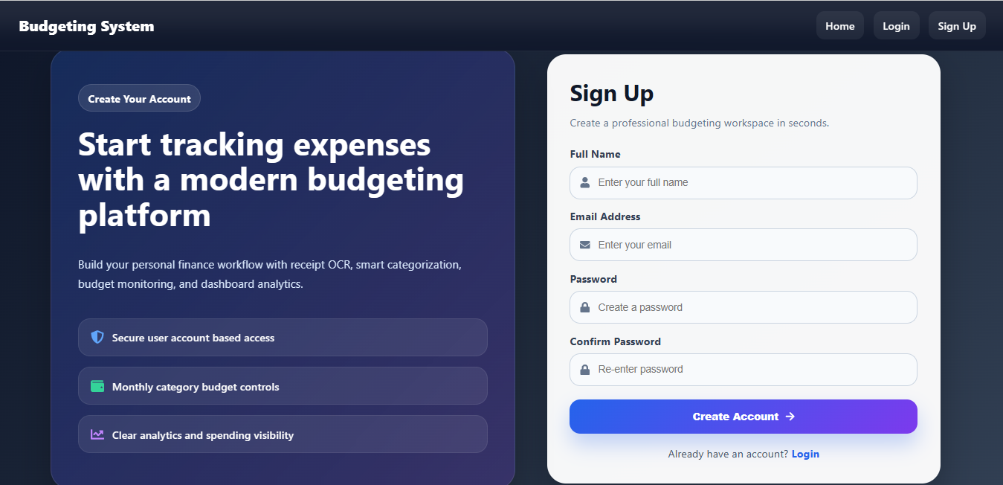
Figure 4.3: User Registration Interface for Creating a New Account
4.3 Frontend Implementation and User Experience
The frontend interface has been developed with a high focus on usability and accessibility. The key features include authentication of users, receipt uploading, and a financial dashboard. The interface will simplify the complicated financial processes and encourage frequent interactions with the users.
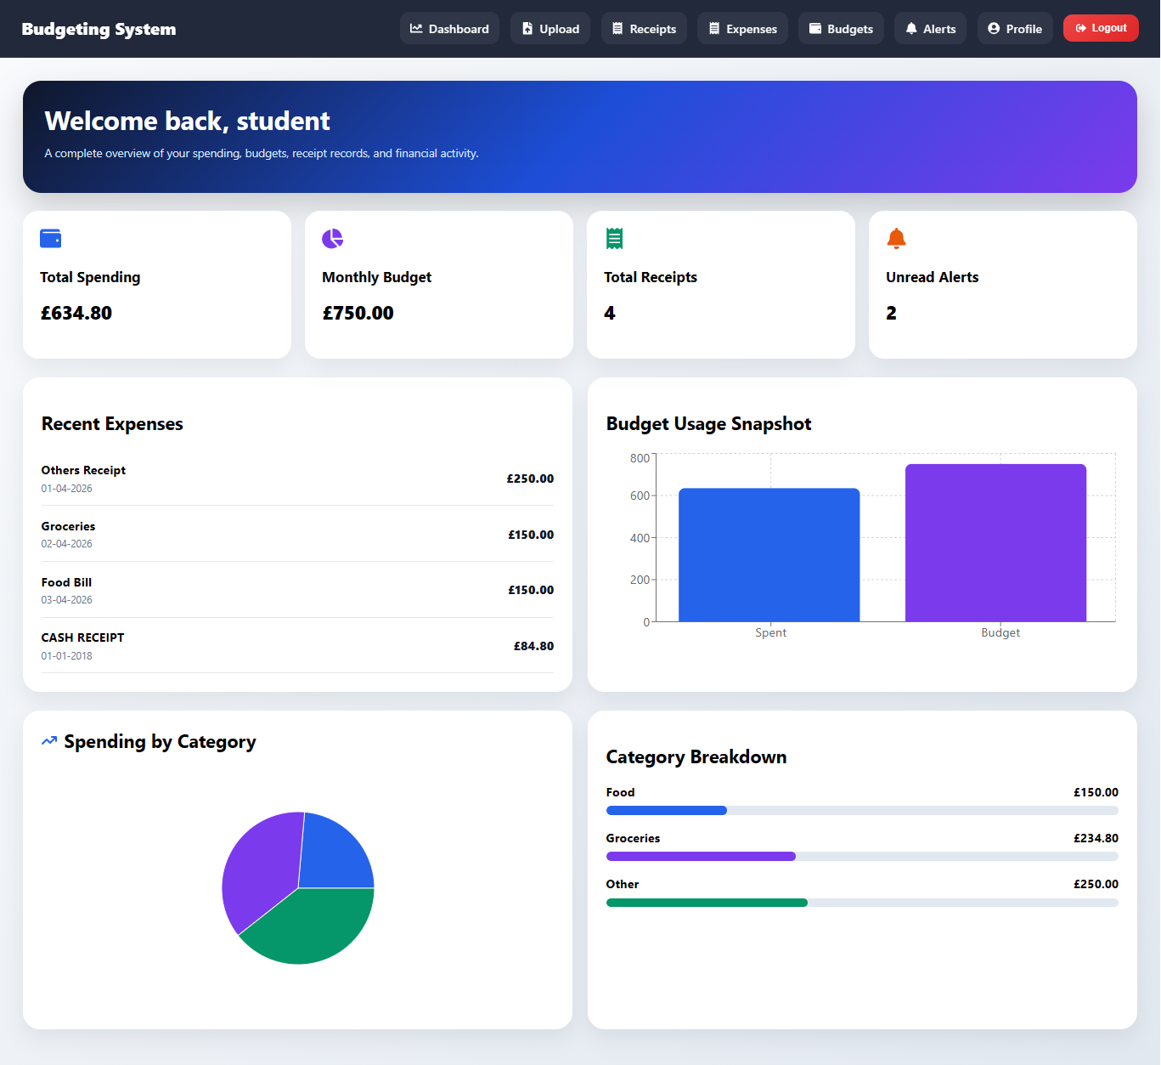
Figure 4.4: Frontend Main Dashboard OCR Budgeting System
The user effort reduction is a critical point of view that should be successful at the frontend. The option of uploading receipts is particularly important as the entry point into the entire system. The system adheres to the trends of the real life use as it allows users to capture pictures with their devices.
The dashboard provides a graphical representation of financial data hence enabling the user to have an idea of their spending behavior within seconds. The usefulness of these visualizations though, is in the clarity and applicability of these visualizations. The interfaces should be designed with great care as too complicated or too cluttered interfaces may decrease usability.
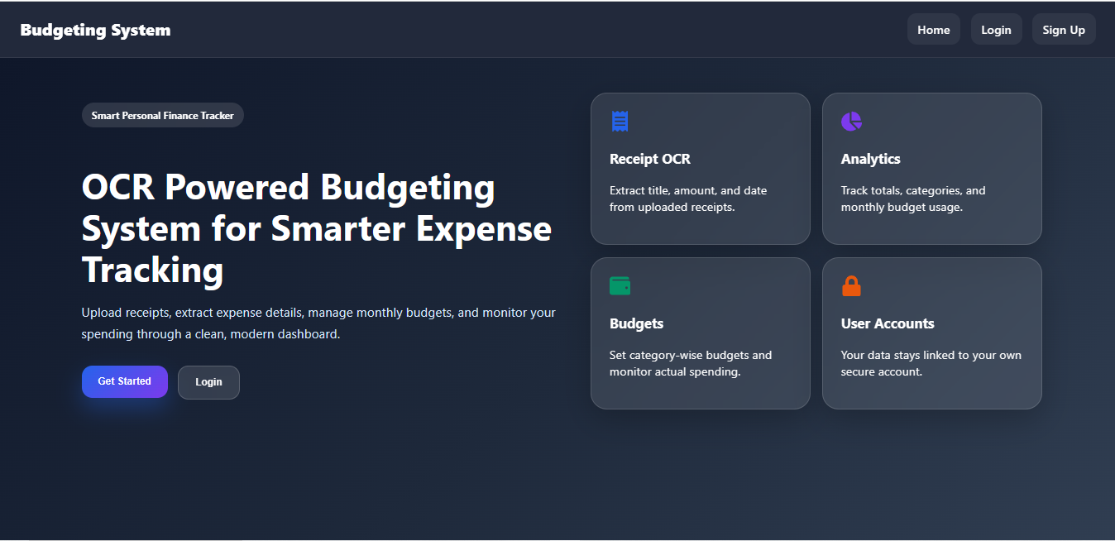
Figure 4.5: Frontend Home OCR Budgeting System

4.4 Backend Implementation and Data Processing
The system has the backend as the central processing unit which undertakes OCR functions, data parsing and database interactions. Asynchronous processing is possible with the use of Python, and it is crucial to process images and API requests.
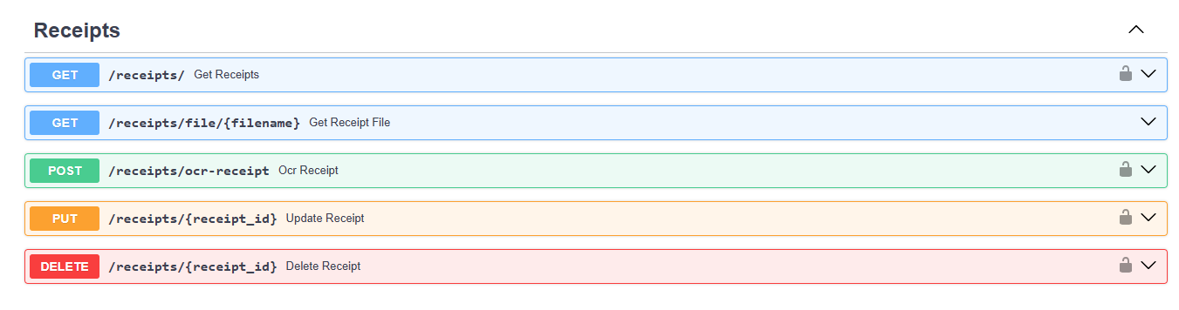
Figure 4.6: API Managing OCR Receipts

Another important aspect of the backend is the OCR processing pipeline. This pipeline entails image processing, text recognition and generation. Even though modern OCR engines are very accurate, they are not error-free. The errors in text recognition can be caused by the differences in the nature of the reception, light conditions, and the quality of the image (Lombardi and Marinai, 2020).
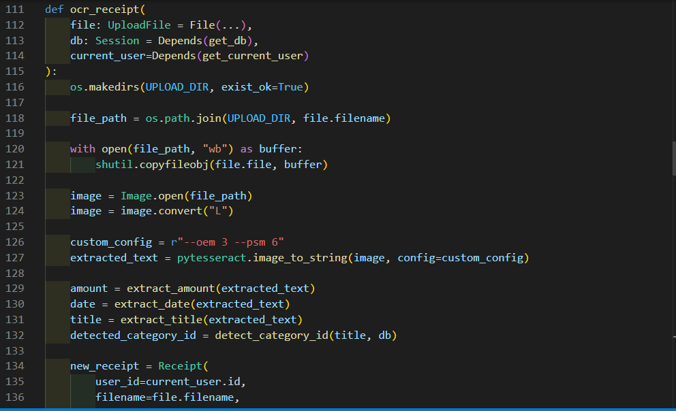
Figure 4.7: backend Managing OCR Receipts
The effects of these problems are minimized by preprocessing techniques such as noise removal and thresholding. These techniques are very useful in improving the precision of OCR and they complicate computation. This brings out a trade-off between performance and accuracy that should be handled with care.

4.5 Data Parsing and Validation
After extraction of text, the system should be able to translate unstructured OCR data into structured data. This is done by parsing and validation. Rule based methods, including regular expression and key word matching are used to identify key fields like amounts of transactions and data.
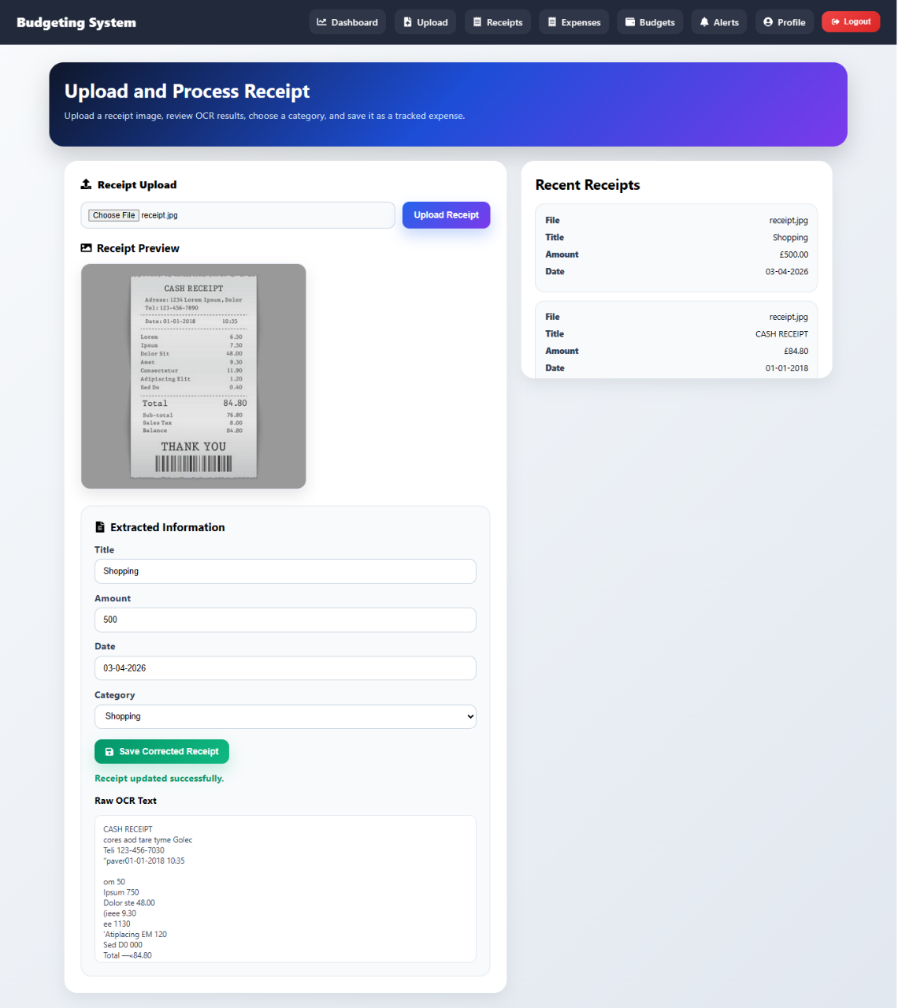
Figure 4.8: Frontend Uploading and Managing OCR Receipts
Although rule-based methods are effective and easy to use, they are inflexible. Unusual receipts are not easily read and hence they may be inaccurate. This limitation means that the system can be improved in the future with more advanced procedures, such as machine learning-based parsing.
There are validation mechanisms that are put in place to have data accuracy. These are format checks, removal of duplicates and numerical verification. These are required to maintain integrity of data particularly in financial systems where errors may be quite expensive.

4.6 Database Implementation and Performance
The database is deployed with the help of a structured relational model, in which tables are utilized to describe users, transactions, receipts and budgets. The relationships between these tables are enforced by foreign keys which give consistency and integrity.
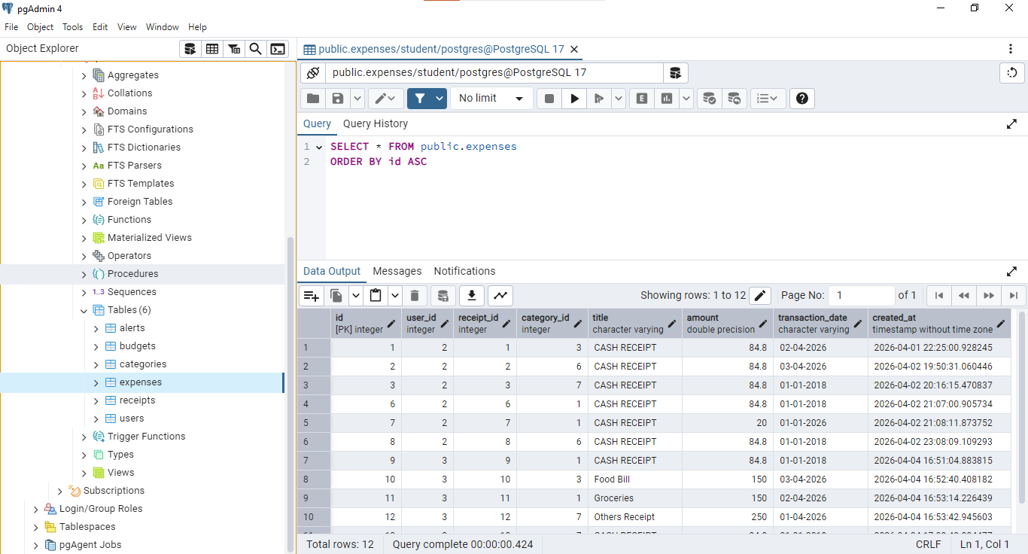
Figure 4.9: Database schema showing all Tables
More importantly, a relational database would be appropriate since the financial information is organized. However, once the system is scaled, the performance will be problematic particularly when working with large data sets. Indexing and query optimization techniques are used to solve these problems and improve the speed of data retrieval.
The database design also supports complex queries, but it is also able to provide detailed financial analysis. This feature plays an important role in the development of insights such as expenditure trends and budgetary comparisons.

4.7 Budget Monitoring and Automation
Budget monitoring engine is one of the key features of the system that provides real-time analysis of the spending of the user. This system offers real-time feedback to the users through continuous comparison of costs with the set budgets.
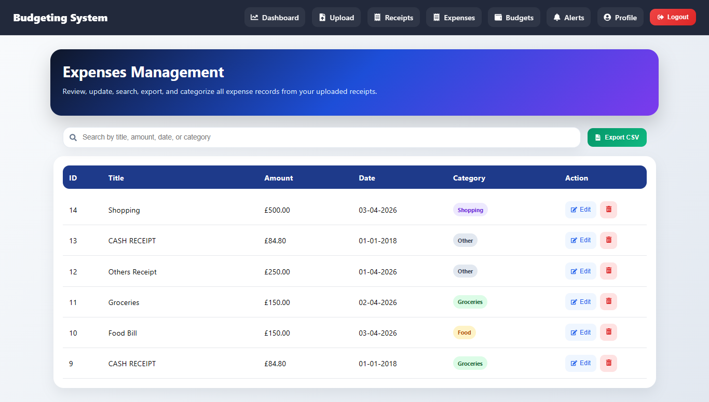
Figure 4.10:Real-time analysis of the spending of the user
This automation is very progressive as opposed to the manual calculations that are used in the traditional budgeting process. Real-time feedback has been pointed out to enhance financial discipline and decision-making (Xiao and O’Neill, 2016).
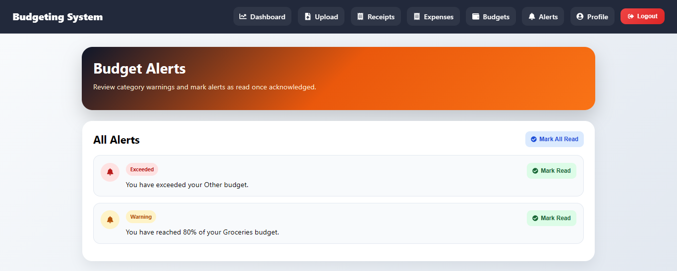
Figure 4.11: Real-time alerts of the spending of the user
Nevertheless, this module requires the accuracy of underlying data in order to be effective. Other errors may be caused by OCR or parsing and this highlights the importance of ensuring that the processing of data is also accurate.
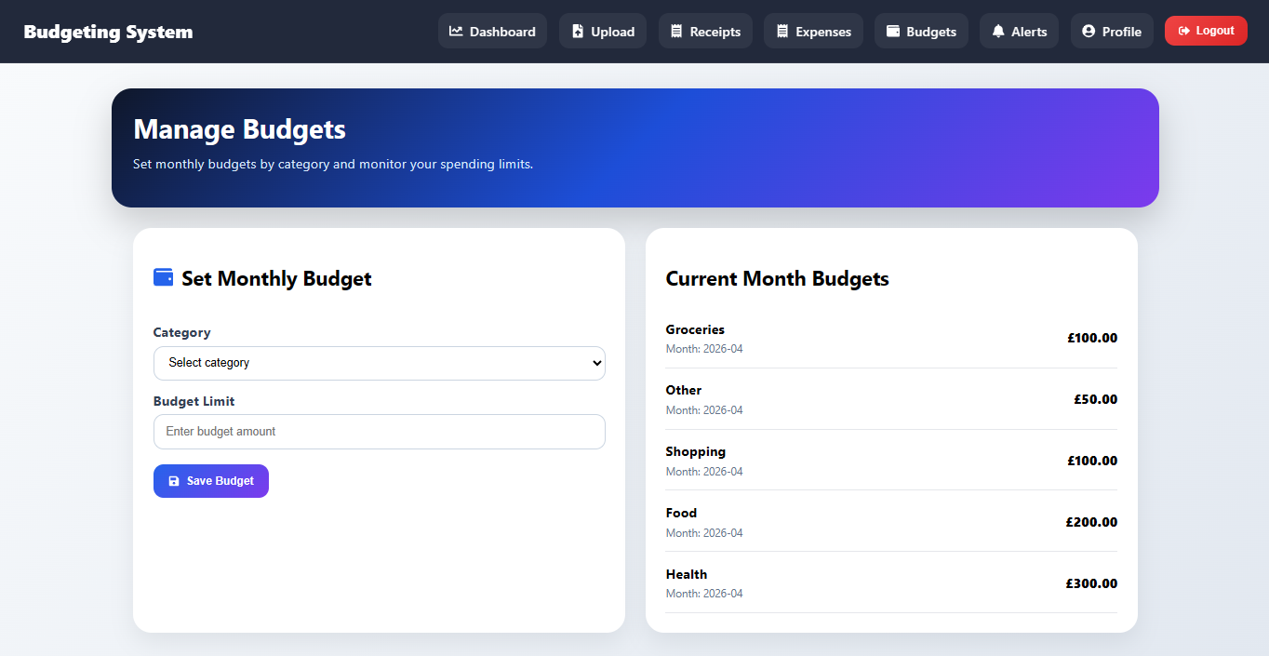
Figure 4.12: User setting monthly budget for spending

4.8 Data Visualisation and User Engagement
The data visualisation module provides an interpretation of financial data in its raw form that is useful. The charts and dashboards enable the users to have a clear view of their financial status and make wise decisions.
Figure 4.13: The charts and dashboards shows the users to have a clear view of their financial status and make wise decisions.
To speak critically, visualisation is not an aesthetic feature but a functional aspect of the system. Good visualizations decrease the cognitive load and enhance user comprehension (Few, 2013). However, inappropriate drawing of images can be counterproductive, and the consequences are disorientation and loss of interest.
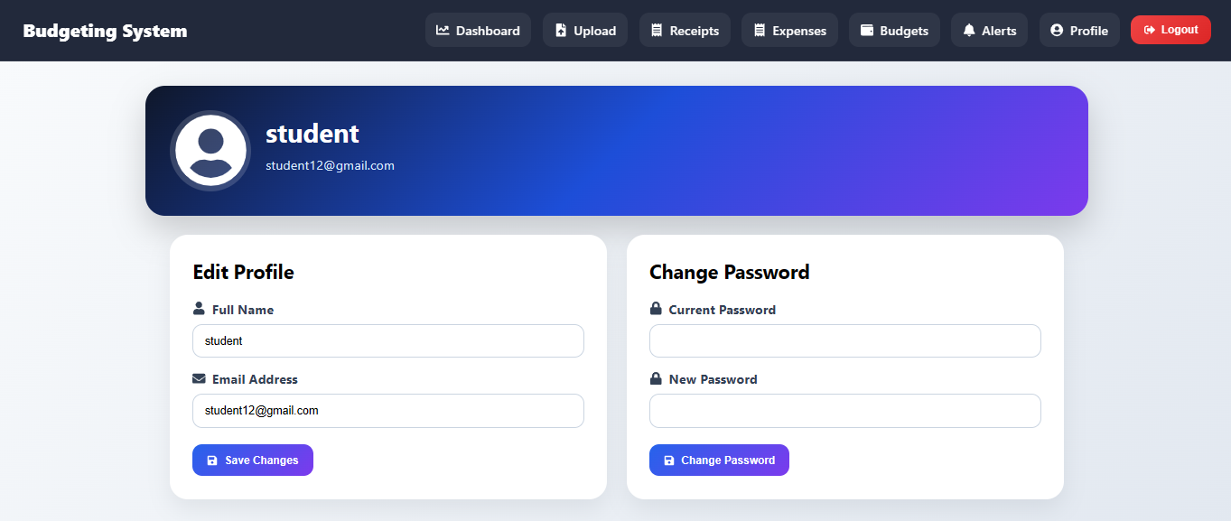
Figure 4.14: User setting the profile
Another factor is interactivity. Filtering, drill-down analysis and others aid in enhancing user experience because they allow users to view data in their own way.
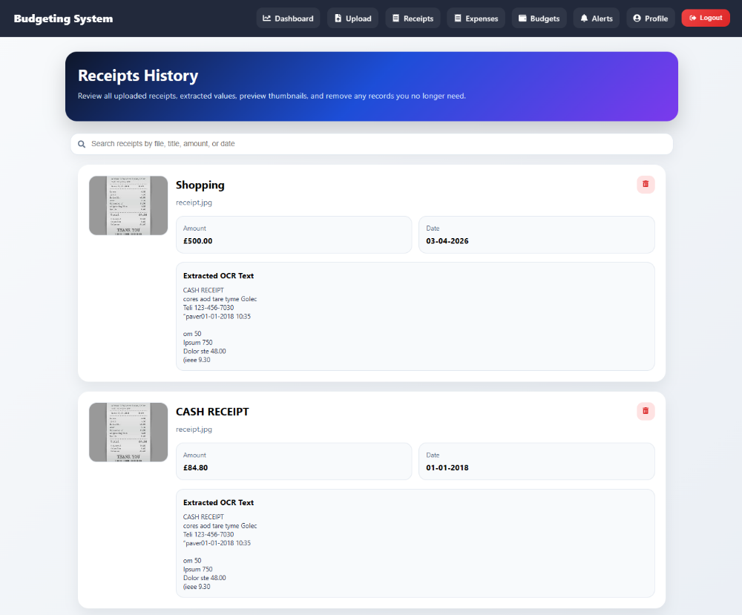
Figure 4.15: Receipts managed that are uploaded for OCR
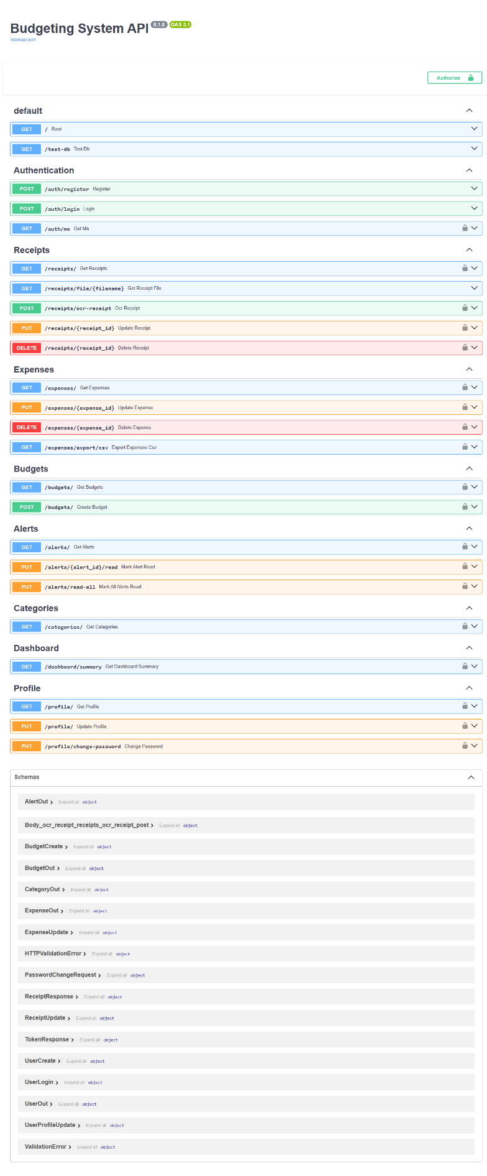
Figure 4.16: Backend API in Python for OCR budgeting system

4.9 Testing, Challenges, and Limitations
Unit and integration testing was done to test the functionality and reliability of the system. It was found that tests had a number of challenges particularly in accuracy of OCR and data extraction.
Addiction to image quality is among the significant constraints. Poor images are a severe performance-killer of OCR and affect the accuracy of the whole system. Even though, preprocessing methods alleviate this issue, they do not eliminate it.
The other difficulty is the different receipt formats. The weakness of the current implementation is that the rule-based parsing algorithm is not very effective in non-standard layouts.

4.10 Security and Ethical Considerations
Due to the sensitivity of financial data, security is a major issue of concern with the system. Measures that are taken to secure user information include user authentication, secure communication between the API and data encryption.
Ethically, users need to control their data. The use of data and the secure storage practices should be open and must be employed as a source of building trust and acceptance of the system.
The chapter has been critical in reviewing the implementation of the proposed system with its strengths and limitations. The suggested solution is possible because of OCR, database systems and budgeting logic integration. However, there are problems, which relate to OCR accuracy, data mining, and scalability of the system, which ought to be addressed to improve the performance.
Overall, the implementation provides a good foundation on how the effectiveness of the system can be checked and it will be dealt with in the next chapter.

Chapter 5: Evaluation and Results
In this chapter, the performance, usability, and overall effectiveness of the proposed database-based budgeting system along with the OCR technology will be evaluated. The evaluation plays a crucial role in determining whether the system is able to control the weaknesses that were noted in the earlier chapters particularly those that relate to manual data entry, disjointed financial records and lack of engagement with the user.
The testing is multi-dimensional because it takes into account the OCR accuracy, the system usability and the overall performance. Additionally, the critical comparison of the results with the existing systems and the literature available is also done so as to establish the contribution and value of the solution proposed. This comparative analysis is needed so as to demonstrate the academic and practical utility of the system which would be required in an assessment on the level of First-Class.

5.1 Evaluation Framework
The evaluation plan will align with the research objectives as outlined in Chapter 1. It is worried about three key dimensions:
- OCR Accuracy and Data Extraction Quality
- Usability and User Experience
- System Performance and Efficiency
Each dimension is measured both qualitatively and quantitatively as a full assessment of the system.

5.2 OCR Accuracy and Data Extraction

5.2.1 Evaluation Approach
An ultimate factor in the effectiveness of the system is the precision of the OCR. The system was assessed by testing the system to several receipt images, of different quality, format, and complexity. The extracted data were compared with manually recorded ground truth values to measure accuracy.
Accuracy was evaluated on the basis of:
- Correct identification of key fields (date, vendor, total amount)
- Completeness of extracted data
- Error rate in text recognition

5.2.2 Results and Analysis
The results indicate that the OCR module can be effective under the good environment in which the accuracy of clear and well-structured receipts is high. All major fields such as total amount and date were determined accordingly. This is consistent with the results of Neng (2022) that indicate that contemporary OCR systems may be highly accurate when they are used on domain-specific documents.
The system is however sluggish when dealing with poor quality images or receipts with complex layouts. Problems like text blurring, bad lighting, and non-standard formatting lead to a misinterpretation or incomplete extraction. The results are consistent with Lombardi and Marinai (2020), who note the issues of OCR in the real world.
An important point that can be made is that OCR technology is a good technology but it is not a flawless one. Mistakes in text extraction directly affect the following stages of text processing like parsing and budgeting. This underscores the need to have strong preprocessing and validation processes.

5.2.3 Comparison with Existing Approaches
The OCR based system saves user a lot of effort and time than the traditional manual data entry. However, it still may happen that manual input is more accurate, particularly when the receipts are more complex.
The available commercial implementations often rely on bank integrations and are not based on scanning of receipts. Bank integration provides the right data, but it does not document cash transactions. The proposed system fixes this limitation because it allows tracking receipts and thus providing a more comprehensive solution.

5.3 Usability and User Experience

5.3.1 Evaluation Approach
It was tested by the use of user interaction tests and it consisted of:
- Ease of navigation
- Task completion time
- User satisfaction
These activities involved the uploading of receipts, the viewing of transactions and the tracking of budgets. Feedback was received to evaluate the general user experience.

5.3.2 Results and Analysis
The results indicate that the system has a user friendly interface which ensures that it is easy to monitor finances. The upload feature was also rather popular since it does not involve any data entry. The users said that this saved them much work on expenses monitoring.
The dashboard also worked well to display financial information in an understandable and easy to access way. Charts and summary of presentation provided users with a quick overview of their spending habits.
However, there were some usability concerns. An example is that users encountered difficulties when manual corrections to OCR errors were required. This underscores a drawback of the system in terms of automation. Though automation conserves labor, it must be precise enough so that users can rely on it.

5.3.3 Comparison with Literature
The findings align with the Technology Acceptance Model (Davis, 1989) that concentrates on the worth of the perceived usefulness and ease of use. Automation features of the system increase perceived usefulness, and ease of use is increased through the use of an intuitive interface.
One of the clear advantages of the proposed system compared to the current budgeting applications is that there is no manual input. As research by Haddad and Hornuf (2019) suggests, one of the main factors that lead to user disengagement is manual data entry. This problem is taken care of in the system, and this is why it is more usable.

5.4 System Performance and Efficiency

5.4.1 Evaluation Approach
The basis of measuring system performance was:
- Response time
- OCR processing time
- Database query efficiency
These measurements were taken when the system was operating under normal conditions of use.

5.4.2 Results and Analysis
The system showed reasonable performance in all measures. The OCR processing time was decent, and it depended on the size and complexity of the image. Database queries could be run efficiently through indexing and optimized schema design.
That said, it was discovered to be poor when working with large images or many requests simultaneously. This underscores the problem of scalability, especially in real world applications where there are a large number of users.
Importantly, the system is effective as a prototype, but may require optimization to support large scale. Some of the techniques that might improve performance include parallel processing and cloud-based infrastructure.

5.5 Effectiveness of Automated Expense Tracking
One of the key objectives of the system is to compare the effectiveness of the automated monitoring of costs and that of the manual system.

5.5.1 Findings
The results indicate that automated tracking could make tracking far more reliable and easier to use. Users will accrue more expenses when the process is simplified. This is consistent with the behavioral studies which suggest that reduced effort will result in a higher level of compliance with financial practices (Xiao and O’Neill, 2016).
However, automation introduces new problems, particularly in regard to precision. The system would save on effort, but it would require some intervention by the users to correct some errors. This means that a combination of automation and user verification can be the most effective.

5.6 Critical Discussion of Findings
The results of the evaluation provide the strengths and limitations of the proposed system.

Strengths
- Great decrease in manual data entry
- More interaction with the user through automation
- Bringing together of OCR and database systems
- Enhanced financial awareness through visualisation

Limitations
- The quality of OCR recognition is subject to image quality
- Parsing errors affect data reliability
- High-load scenarios with scalability issues
- Inability to adapt well to different receipts
One of the most important observations is that the system does not remove all of the key usability issues, though it mitigates them. This is an indication of how difficult it is to incorporate several technologies into a coherent user experience.

5.7 Comparison with State-of-the-Art Systems
The proposed system was compared with the solutions available regarding functionality, ease of use, and data capture functionality.
Traditional budgeting tools are quite manualistic and this makes them less interactive. On the other hand, data capture is automated by the proposed system, which is a significant weakness.
Bank built in systems are precise but lack cash transactions. The system is complementary to these systems since it provides the ability to track by receipt.
In research terms, most research is done on individual components such as OCR or budgeting systems. The suggested system puts together these elements, offering a more holistic solution. This combination is a huge contribution to the field.

5.8 Validity and Reliability
The validity of the evaluation is demonstrated by real-life data and real-life testing scenarios. However, the generalizability may be affected by the small sample, as well as by the prototype nature of the system.
Testing consistency is achieved and validation is used to provide reliability. However, more testing using larger datasets is needed to establish reliability in the long term.

Chapter 6: Discussion
The purpose of this discussion is not only sufficient to summarize results but also to evaluate the usefulness of the proposed system in relation to how it will be able to address the identified research problem and contribute not only to the academic knowledge but also to the practical applications.
The discussion is based on the main themes that have been revealed after the assessment, such as automation of financial data capture, OCR performance, usability, system integration, database reliability, and behavioral impact. This chapter will present the critical interaction with the area of subject matter by comparing the empirical findings with the prior studies in order to identify the similarities and differences.

6.1 Automation and Reduction of Manual Effort
Another primary objective of this study was to limit the use of manual data entry which has always been cited as a significant limitation of the traditional budgeting systems. The demonstration of the tested integration indicates that the integration of OCR can significantly conserve the efforts of the user since it will help to automatize the process of retrieving information about the transactions in the receipts. The outcome is highly aligned with the literature available, as it highlights the issue of manual input as one of the main factors of user disengagement in financial applications (Haddad and Hornuf, 2019).
On the behavioral side, it is significant to reduce the effort by ensuring that the financial monitoring is carried out on a regular basis. Xiao and O’Neill (2016) state that people tend to be more willing to monitor their finances when it is easy to use and does not need significant cognitive effort. This theoretical position aligns with the suggested system because it makes the process of capturing data simple therefore lowering the entry barriers. As a result, the users would be more inclined to use the system on a habitual basis, which may lead to greater financial awareness and decision-making.
Nevertheless, a closer look will show that automation is not all smooth. The fact that OCR errors require manual corrections leads to the fact that the desired decrease in effort is compromised to some extent. This is the limitation of the application of automated systems to the real world. As Lombardi and Marinai (2020) stress, the performance of OCR is very sensitive to the quality of images and the organization of documents, and such factors can bring differences.
Therefore, despite the fact that the system is going to be a great improvement over fully manual means, it will not eliminate human involvement. It means that the hybrid system of automation with validation by the user could be an optimal option. This type of balance would be effective and precise because it would defeat the deficiencies that have been experienced in the current implementation.

6.2 OCR Performance and Data Extraction Challenges
OCR performance is measured and reveals the merits and drawbacks of the current text recognition devices. It is also remarkably precise with well-organized and understandable receipts, which is evidence of the advancements made in OCR by the machine learning and deep learning approaches (Bengio, Goodfellow and Courville, 2017). However, when using poor quality images, different lighting conditions, or intricate receiver designs, the performance suffers significantly.
The discovery is consistent with those of Neng (2022), who presents document format variability and image quality as a chronic issue in OCR applications. Although technology has improved, OCR technology continues to fail on real-world data and in such cases, the conditions are usually unpredictable. This is a grave limitation of using OCR in the extraction of financial information.
The other important problem found in this study is that OCR output does not have semantic understanding. The system can get the text but not always comprehend meaning or context of the information. Rule-based parsing is inflexible since it is based on the patterns and keywords that have been previously identified. Lazic (2020) notes that these techniques are limited to the processing of all kinds of and unstructured information, particularly when a receiver cannot be placed in a conventional format.
Among the lessons that can be learned in this analysis is that OCR is not the solution but a component of a bigger data processing pipeline. Preprocessing, parsing and validation mechanisms should be combined to increase the overall accuracy and reliability. This system level perspective is necessary to eliminate failures of both isolated technologies and to achieve a more solid solution.

6.3 Usability and User Engagement
One of the aspects of the success of any financial application is its usability, and the findings of the current study indicate that the provided system is a significant contributor to user experience. Scanning receipts and interactive dashboards are some of the features that render the system less complex and more accessible and interactive when it comes to financial tracking.
These results can be compared to the Technology Acceptance Model (Davis, 1989), which concedes that perceived usefulness and ease of use are the factors that predetermine the adoption of the technology by users. Data entry automation improves perceived usefulness but the user-friendly interface simplifies its use. All this results in greater user satisfaction and engagement.
In addition, the cognitive load reduction supports automation of cognitive load and the results of Naik et al. (2024) that simplified interaction and visual feedback are necessary to sustain engagement in financial applications. The system allows users to make informed decisions and learn their financial position in a very short time by presenting data in a clear and visually appealing way.
However, usability still remains a problem. The need to correct OCR errors can disrupt the user experience and reduce confidence in the system. In addition, the users may need time to accustom to new ways of interacting particularly where they are accustomed to the previous way of budgeting. This highlights the importance of coming up with systems that are not only automated, but are also versatile and user controllable.

6.4 Integration of Technologies
The other contribution of the study is that a number of technologies including OCR, relational databases, and budgeting algorithms were integrated with one system successfully. Though these components have been researched individually in the past, there are limited studies on the combined use of these components (Raoui-Outach et al., 2017).
The findings indicate that integration enhances the functionality of the systems due to the fact that it enables the free flow of data between the receipt capture and financial analysis. This is a holistic solution to real life problems in comparison to the standalone solutions since it considers the general workflow of the tracking of funds.
There is also a lot of complexity that comes with integration. Issues of interest include the compatibility of different components, the performance of the system and the errors in the modules. According to Pressman (2014), more functionality of the system may result in a higher complexity and, therefore, maintainability and scalability.
The proposed system has this functionality-complexity trade-off. Integration is known to be more useful and efficient, but it should be optimized and designed to ensure reliability. This emphasizes the necessity to adopt modular architectures and effective testing plans.

6.5 Database Design and System Reliability
The relational database is essential in maintaining reliability and consistency of the database. The results of the evaluation indicate that the database is useful in the storage, retrieval and real time budgetary tracking. This is in line with Elmasri and Navathe (2016), who underscore the significance of organized data management in financial systems.
The normalization and referential integrity are employed to ensure that data is stored in an effective and consistent way and the elimination of the possibilities of errors. This is especially so in financial applications, where accuracy of data is paramount.
Scalability is however an issue. Even though the relational model is good in the prototype, it may require some optimization to be implemented on a large scale. Stonebraker and Çetintemel (2018) argue that the conventional database system may not be capable of dealing with a great deal of data, which means that hybrid or distributed systems should be implemented.

6.6 Behavioral Impact and Financial Awareness
Real-time feedback and visual insights have been found to have a positive impact on user behaviour in the system. Users gain more consciousness about their spending habits and are in a better position to control their money. This supports the behavioral theories that support the significance of feedback in decision-making (Xiao and O’Neill, 2016).
Nonetheless, it is not clear whether this will be transformed into long-term behavior change. The most important aspects that must be taken into consideration to keep the engagement continuing are motivation, trust, and system reliability, which explains the significance of future research.

6.7 Limitations and Future Improvements
Though this system has several benefits, it is characterized by several limitations that include inaccuracy in OCR, use of rules in parsing and scalability. The next generation of the work should be aimed at the implementation of machine learning methods and the optimization of the performance of systems based on clouds.

Chapter 7: Conclusion and Future Work
This chapter contains the conclusion of the research and the possible directions of the future works. The design and development of the automated personal financial management system that integrates the Optical Character Recognition (OCR), data processing, and budgeting processes were the subject of concern in the paper. The final aim was to reduce manual labor as well as to simplify it and provide the user with an additional control and management of their finance. The chapter will summarize the key findings, discuss the extent to which its aims were achieved, and make comments on constraints and recommendations on how the research could be improved in future.

7.1 Summary of Key Findings
This research shows the proposed system has effectively overcome a number of limitations that exist in traditional budgeting systems. Automation in tracking of expenses by scanning of receipts with the help of an OCR is one of the greatest additions. This capability saves time that could be wasted in manually entering data which is usually subject to errors of human being. Consequently, users will be able to capture transaction data fast and keep more accurate financial records.
There is also good integration of various elements to the system, such as OCR processing, database management, and budgeting logic. The result of this integration guarantees a seamless process of data capture to analysis and visualization. Financial records can be readily stored and retrieved through the use of a structured database, which processes real-time updates and reporting.
Referring to the aspect of usability, the system offers a convenient user interface which makes it easy to track finances. Such characteristics as dashboards, classified costs, and graphical overviews help to achieve better user interactions. All these design features are in line with the common rules of usability and ensure that the system is usable even by the users who possess little technical knowledge.
The other important conclusion is that the system is able to raise financial awareness among the users. Users can make sound financial decisions because they can retrieve instantaneous information on spending habits and budget positions. This allows us to conclude that digital instruments can contribute to responsible financial behaviour to a large extent.

7.2 Achievement of Research Objectives
The research objectives that were established at the very emergence of the research have been met to a significant level:
- Expense Tracking: OCR integration is a successful method of automating the process of scanning the receipts transaction data, which is time and energy saving.
- Enhanced Data Management: The relational database offers an efficient storage, consistency and retrieval of financial information.
- Simple to operate Interface: The system is user friendly, thereby making it more usable and accessible.
Budget Monitoring and Analysis: The system assists the user to track the spending, categorize costs and budgets effectively.
Overall, the system meets the intended goals by combining automation, usability, and functionality into one personal financial management tool.

7.3 Limitations of the Study
Despite the strong points of the system, there are several limitations to the system, and these should be considered.
First, the quality of images on the input influences the accuracy of the OCR. Poor lighting, unreadable text, or inappropriate receipt layout can reduce the precision of the extraction process, whereby a user is required to make some modifications manually. This is a weakness meaning that though OCR technology is effective, it is not fully useful in real environment.
Second, the system has rule-based parsing to comprehend extracted text. It may be rigid and contain issues with complex or non-normal receipt layouts. This can be achieved with more sophisticated means such as the understanding of texts with the help of machine learning.
Third, the system has been experimented in a restricted environment with small data sets. Therefore, it has not been put to a complete test as to its performance under large scale or highly diverse conditions. Real world deployment is still in consideration of scalability and performance optimization.
Lastly, the user behaviour and long-term engagement was not researched in detail. Though the initial scores of usability are positive, long-term use needs additional intervention of other factors such as motivation, consistency, and value perception.

7.4 Practical Implications
The reason is that the results of this research may be practically implemented by people and designers of financial management systems. To the users, this system offers them an easy and effective means to monitor the costs, budgets and have an insight into their spending patterns. This would assist in the enhancement of good financial discipline and sound choices.
To developers, the study indicates that there is the desire of integrating different technologies to solve real life problems. The interdisciplinary approach is suggested in connection with OCR, database systems and the design of a user interface as the method of enhancing the functionality of a system. In addition, the findings show that the factors of design in a system are usability and automation which are important.

7.5 Future Work
The opportunities to expand and improve the existing system exist. These consist of technical improvements and functional additions.

7.5.1 Integration of Machine Learning
In the future, the system can be improved using machine learning algorithms to improve the accuracy of OCR and make the process of expenses classification automated. Models would not just obey the regulations and attempt to enhance the precision or personalisation but will learn as the user behaviour and get more precise or personalised.

7.5.2 Natural Language Processing (NLP) Enhancements
The system can also be improved by incorporation of the Natural Language Processing (NLP) techniques which can enable the system to understand and interpret unstructured data even better. As an example, NLP can be used to extract meaningful information in the receipts with varying formats or it could be used to obtain smart summaries of spending behaviour.

7.5.3 Mobile Application Development
A mobile version of the system would be very helpful to make it much more accessible and usable. Due to the necessity to handle receipts on a regular basis, mobile application with an in-built camera would facilitate real-time scanning and processing. The push notification could also be used to send reminders and financial alerts.

7.5.4 Cloud-Based Architecture
Migration of the system to cloud based infrastructure would increase, scalability, performance and access to data. Cloud storage would facilitate the customer to access his/her financial information on a variety of devices with an assurance of backup and synchronization.

7.5.5 Enhanced Data Visualization
In the future, this may be enhanced with more sophisticated data visualization display, which might be interactive charts and predictive analytics dashboards. These would help the user to make more sense and predictions of the trends, how the expenses will be (most likely) and budgeting more efficiently.

7.5.6 Security and Privacy Improvements
As financial data is very sensitive, the work in the future is to be concentrated on the enhancement of data security. The protection of the data integrity would be enhanced through encryption and proper authentication and compliance with the data protection standards, thus making the users more trusting of the system and enhancing its reliability.

7.5.7 User Behaviour Analysis
Future researches can be centred on longitudinal user behaviour and patterns of engagement. Longitudinal studies would provide an understanding of how the users will utilize the system in the long term and how the system will revolutionize their financial patterns.

7.6 Final Remarks
Finally, this study has shown that an integrated, OCR-based personal financial management system can positively contribute to the process of users tracking and managing their finances. The system will offer a viable solution to the typical issues of the traditional approach to budgeting such as removing manual work, enhancing the ease of use and the delivery of real time value.
Though the system has some shortcomings, it lays a solid ground towards improvement in the future. With more functionality added to the system in other aspects such as machine learning, mobile access, and cloud connectivity, it will be capable of becoming a smarter and scalable financial management service.
On the whole, the research adds to the on-going research on digital financial tools by introducing a solution that would integrate automation, usability, and data-driven insights to help in making better financial decisions.

References
Baker, T. and Dellaert, B. (2017) ‘Regulating robo-advice across the financial services industry’, Iowa Law Review, 103, p. 713.
Bengio, Y., Goodfellow, I. and Courville, A. (2017) Deep Learning. Cambridge, MA: MIT Press.
Chen, P. P. S. (1976). The entity-relationship model, toward a unified view of data. ACM transactions on database systems (TODS), 1(1), 9-36.
Clausner, C., Antonacopoulos, A., & Pletschacher, S. (2017, November). Icdar2017 competition on recognition of documents with complex layouts-rdcl2017. In 2017 14th IAPR International Conference on Document Analysis and Recognition (ICDAR) (Vol. 1, pp. 1404-1410). IEEE.
Davis, F.D. (1989) ‘Perceived usefulness, perceived ease of use, and user acceptance of information technology’, MIS Quarterly, 13(3), pp. 319–340.
Dieter, M. and Tkacz, N. (2020) ‘The patterning of finance/security: A designerly walkthrough of challenger banking apps’, Computational Culture, (7).
Elmasri, R. and Navathe, S.B. (2016) Fundamentals of Database Systems. 7th edn. Harlow: Pearson.
Fernandes, D., Lynch Jr, J. G., & Netemeyer, R. G. (2014). Financial literacy, financial education, and downstream financial behaviors. Management science, 60(8), 1861-1883.
Few, S. (2013) Information Dashboard Design: Displaying Data for At-a-Glance Monitoring. 2nd edn. Burlingame: Analytics Press.
Fikri, N., Rida, M., Abghour, N., Moussaid, K. and El Omri, A. (2019) ‘An adaptive and real-time based architecture for financial data integration’, Journal of Big Data, 6(1), p. 97.
Haddad, C. and Hornuf, L. (2019) ‘The emergence of the global fintech market: Economic and technological determinants’, Small Business Economics, 53(1), pp. 81–105.
Hevner, A.R., March, S.T., Park, J. and Ram, S. (2004) ‘Design science in information systems research’, MIS Quarterly, 28(1), pp. 75–105.
Hilgert, M.A., Hogarth, J.M. and Beverly, S.G. (2003) ‘Household financial management: The connection between knowledge and behavior’, Federal Reserve Bulletin, 89, p. 309.
Jiang, Z., Chen, Y., Zhang, Y., Ge, Y., Yin, F. F., & Ren, L. (2019). Augmentation of CBCT reconstructed from under-sampled projections using deep learning. IEEE transactions on medical imaging, 38(11), 2705-2715.
Karlan, D., McConnell, M., Mullainathan, S., & Zinman, J. (2016). Getting to the top of mind: How reminders increase saving. Management science, 62(12), 3393-3411.
Katti, A. R., Reisswig, C., Guder, C., Brarda, S., Bickel, S., Höhne, J., & Faddoul, J. B. (2018). Chargrid: Towards understanding 2d documents. In Proceedings of the 2018 Conference on Empirical Methods in Natural Language Processing (pp. 4459-4469).
Kirk, A. (2019) Data Visualisation: A Handbook for Data Driven Design. London: Sage.
Lazic, M. (2020) ‘Using natural language processing to extract information from receipt text’.
Lombardi, F. and Marinai, S. (2020) ‘Deep learning for historical document analysis and recognition: A survey’, Journal of Imaging, 6(10), p. 110.
Lusardi, A. and Mitchell, O.S. (2014) ‘The economic importance of financial literacy: Theory and evidence’, Journal of Economic Literature, 52(1), pp. 5–44.
Mijić, M. and Ćebić, B. (2023) ‘Mobile applications for personal finance management: Technology acceptance perspective’, in Digital Transformation of the Financial Industry. Cham: Springer, pp. 273–295.
Naik, S.L., Kumar, G.R., Kiran, A., Ganesh, D. and Madgi, M. (2024) ‘Automating financial management: An exploration of automatic expense tracking systems’, in IEEE Conference Proceedings, pp. 1–5.
Neng, H.Z. (2022) Automated Scanned Receipt Processing with Optical Character Recognition and Machine Learning. Master’s thesis. University of Malaya.
Norman, D. (2013) The Design of Everyday Things. New York: Basic Books.
Pressman, R.S. (2014) Software Engineering: A Practitioner’s Approach. 8th edn. New York: McGraw-Hill.
Ramachandran, S. (2018) Database Management Systems. Delhi: McGraw-Hill.
Raoui-Outach, R., Million-Rousseau, C., Benoit, A. and Lambert, P. (2017) ‘Deep learning for automatic sale receipt understanding’, in Proceedings of the IEEE International Conference on Image Processing Theory, Tools and Applications (IPTA), pp. 1–6.
Silberschatz, A., Korth, H. F., & Sudarshan, S. (2002). Database system concepts (Vol. 5). New York: McGraw-Hill.
Smith, R. (2007) ‘An overview of the Tesseract OCR engine’, in Proceedings of the International Conference on Document Analysis and Recognition (ICDAR), pp. 629–633.
Stonebraker, M. and Çetintemel, U. (2018) ‘One size fits all: An idea whose time has come and gone’, in Making Databases Work: The Pragmatic Wisdom of Michael Stonebraker. Cambridge, MA: MIT Press, pp. 441–462.
Leonard, T. C. (2008). Richard H. Thaler, Cass R. Sunstein, Nudge: Improving Decisions about Health, Wealth, and Happiness: Yale University Press, New Haven, CT, 2008, 293 pp, $26.00.
Venkatesh, V. and Bala, H. (2008) ‘Technology acceptance model 3 and a research agenda on interventions’, Decision Sciences, 39(2), pp. 273–315.
Xiao, J.J. and O’Neill, B. (2016) ‘Consumer financial education and financial capability’, International Journal of Consumer Studies, 40(6), pp. 712–721.
Yigitbasioglu, O. and Velcu, O. (2012) ‘A review of dashboards in performance management: Implications for design and research’, International Journal of Accounting Information Systems, 13(1), pp. 41–59.

